International Journal of Systematic and Evolutionary Microbiology (2014), 64, 271–292 DOI 10.1099/ijs.0.057893-0

Correspondence Wilhelm Foissner wilhelm.foissner@sbg.ac.at
An update of ‘basic light and scanning electron microscopic methods for taxonomic studies of ciliated protozoa’
Wilhelm Foissner
Universita¨t Salzburg, FB Organismische Biologie, Hellbrunnerstrasse 34, A-5020 Salzburg, Austria
This is an update of the review by Foissner (1991). Since then, I have improved some methods considerably. The following methods are described in detail: live observation, supravital staining with methyl green-pyronin, dry silver nitrate impregnation, wet silver nitrate impregnation, silver carbonate impregnation, protargol impregnation (three procedures), scanning electron microscopy, and deciliation. Familiarity with these methods (or modifications) is a prerequisite for successful taxonomic work. No staining method is equally appropriate to all kinds of ciliates. A table is provided which indicates those procedures which work best for certain groups of ciliates. A second table relates to the structures revealed by the procedures. Good descriptions usually demand at least live observation, silver nitrate and protargol or silver carbonate impregnation. Some instructions are provided for distinguishing mono- and dikinetids as well as ciliated and non-ciliated basal bodies in silvered ciliates. Furthermore, I added a section on ‘Deposition and Labeling of Preparations’. All methods work not only with ciliates but also with many other heterotrophic and autotrophic flagellated and amoeboid protists. The brilliancy of silver preparations has tempted some taxonomists to neglect live observation. However, many important species characteristics cannot be seen or are changed in silvered specimens. I thus consider all species descriptions based exclusively on silver slides as incomplete and of doubtful value for both a-taxonomists and ecologists.

INTRODUCTION
The micrographs of various freshwater, marine and soil ciliates published by my colleagues and myself during the past 25 years, most based on the few methods described here and by Foissner (1991), have been widely accepted as being of a high standard. All methods are modifications of techniques which initially did not work well in our laboratory, either because they were incompletely described or too complicated. This paper provides detailed step-bystep protocols for the methods used in our laboratory. For other techniques the reader is referred to the literature cited and to the methodological guides by Kirby (1950), Lee et al. (1985) and Dragesco & Dragesco-Kerne´is (1986).
The basis of most methods and the hunger for beautiful protist preparations, I learned from the literature cited, from laboratory manuals for the microscopic anatomy of plant and animal tissues (e.g. Adam & Czihak, 1964; Romeis, 1968), and in the laboratories of Dr N. Wilbert (Bonn University, Germany; protargol-and wet silver nitrate impregnation) and Professor Dr I. Dragesco (Clermont-Ferrand University, France; protargol impregnation). Most improvements were
Abbreviation: SEM, scanning electron microscopy.
057893 G 2014 IUMS Printed in Great Britain
based on hard experimental work or, rarely, on good luck. As
an example for both, I mention the use of albumized slides (luck) and of a chemical developer (many experiments) for the dry silver nitrate method of Klein (1926, 1943). The results of these modifications were so convincing that I could publish them in Mikrokosmos, a journal for amateur microscopists, when I was just fifteen. Since then, I tried to improve the methods almost continuously, the most recent success being a simple technique for deciliation so that the often complex cortical and ciliary structures can be observed with outstanding clarity (Fig. 6).
In addition, photographic documentation has profited greatly from the digital revolution. The images can be nicely improved and the problem of low focal depth can be overcome by stacking (Fig. 3).
Structures revealed by the methods described and interpretation of silver stains
There is no single method which can reveal all details necessary for a good description of a ciliate. Likewise, no staining method is equally appropriate to all kinds of ciliates. Good descriptions usually demand, as is evident from Tables 1 and 2, at least live observation, silver nitrate and protargol

Table 1.
Structures revealed by the methods described. Table adapted from Foissner (1991)
+
, Good;
++
, excellent,
+
/– &
++
/–, sometimes i.e. depends on species; –, not revealed or poorly preserved.
Structures revealed
Live observation
Methyl
green-pyronin
Dry silver
nitrate
Wet silver
nitrate
Silver carbonate
Protargol
SEM
Shape (Figs 2j, 4a and c, 5 and 6a–d in this paper and figures 2, 10, 13, 16, 21,
24
, 28–32 and 34 in Foissner,
1991)
++
–
+
/–
++
–
++
+
Nuclear apparatus (Fig. 2a in this paper and figures 5, 12 and 31–32 in
Foissner, 1991)
+
++
–
–
++
++
–
Contractile vacuole
++
–
–
–
–
–
–
Excretory pore, cytopyge (Figs 2a and 3a, e in this paper and figures 5, 21 and
1991)
in Foissner,
22
+
/–
–
+
/–
++
+
/–
+
/–
+
Colour
++
–
–
–
–
–
–
Mucocysts (Figs 2i, 3e and 6g in this paper and figures 8, 14 and 17 in
Foissner, 1991)
+
++
/–
+
/–
+
/–
++
/–
+
/–
+
/–
Trichocysts, toxicysts (figure 37 in Foissner, 1991)
++
++
/–
+
/–
+
/–
++
/–
+
/–
+
/–
Cortical granules (figure 38 in Foissner, 1991)*
++
/–
++
/–
–
–
+
/–
+
–
/–
Infraciliature (basal bodies and cilia; Figs 2a, b, d, f–h, j, 3, 4 and 6 in this
paper and figures 1–6, 10, 12, 15, 16, 18, 21–25 and 28–36 in Foissner, 1991)
+
–
/–
+
+
+
++
++
Silverline pattern (Figs 2c, f, g and 3b–e in this paper and figures 7, 15, 19, 20,
, 26 and 35–36 in Foissner,
23
1991)
–
–
++
++
/–
–
–
–
Cortical fibres (Figs 2a, b, h in this paper and figures 5–6, 11–12 and 27 in
Foissner, 1991)
D
–
–
–
–
++
++
–
/–
Cytoplasmic fibres (e.g. myonemes, pharyngeal rods and fibres; Figs 2a, b and
f in this paper and figures 6, 12 and 25 in Foissner, 1991)
+
/–
–
–
–
++
/–
++
–
/–
Surface ornamentation (Figs 4a, e, 5 and 6 in this paper and figures 9 and 34
in Foissner, 1991)
+
–
–
/–
–
–
–
++
Symbiotic algae
++
–
–
–
–
+
/–
–
*‘Cortical granules’ include various extrusive (especially mucocyts or mucocyst-like extrusomes) and non-extrusive structures. They are most pr
ominent and important (and often non-extrusive) in
several hypotrich ciliates (see figure 38 in Foissner, 1991).
D
Two main types of cortical fibres can be distinguished: those associated with the basal bodies (e.g. kinetodesmal fibres, transverse and postciliar
y microtubular ribbons; Fig. 2(a, h) in this paper
and figures 5, 6, 25 and 27 in Foissner, 1991) and those located in the cortical-cytoplasmic boundary (e.g. the infraciliary lattice in several penicu
lines and holophryids; figure 11 in Foissner, 1991).
W.Foissner
272
InternationalJournalofSystematicandEvolutionaryMicrobiology
64
Downloaded from www.sgmjournals.org by
IP: 83.215.4.72
On: Wed, 08 Jul 2015 14:50:20

Table 2. Methods for studying the infraciliature and the silverline pattern of certain groups of ciliates (systematics after Corliss, 1979). Table adapted from Foissner (1991)
+, Recommended; ++, highly recommended; +/–, sometimes useful, depends on species; –, not recommended.
Taxa | Dry silver nitrate | Wet silver nitrate | Silver carbonate | Protargol
Karyorelictida (e.g. Trachelocerca, Loxodes; usually difficult to impregnate) | – | +/– | + | +
Archistomatina (e.g. Alloiozona, Didesmis) | ? | + | + | +
Prostomatina (e.g. Holophrya, Metacystis, Urotricha, Coleps; Fig. 3(d) in this paper and figure 11 in Foissner 1991) | + | ++ | ++ | +
Haptorida (e.g. Enchelys, Spathidium, Didinium, Dileptus; figures 2, 3 and 9 in  Foissner 1991) | +/– | + | + | ++
Pleurostomatida (e.g. Amphileptus, Loxophyllum) | +/– | – | + | ++
Trichostomata (e.g. Plagiopyla, Spirozona, Balantidium, Paraisotricha; special method available (Wolska, 1966) | + | + | + | +
Entodiniomorphida (e.g. Ophryoscolex, Cycloposthium) | ? | + | + | +
Colpodeans (e.g. Colpoda, Woodruffia, Bursaria, Bryometopus; Fig. 3(b, c) in this paper and figures 13–18 in Foissner, 1991) | + | ++ | ++ | +
Synhymeniidae (e.g. Nassulopsis, Chilodontopsis) | + | ++/– | ++ | +/–
Nassulina (e.g. Nassula, Furgasonia; Fig. 2(a-c) in this paper and figures 5–8 in  Foissner, 1991) | +/– | + | ++ | –
Microthoracina (e.g. Microthorax, Leptopharynx) | ++ | + | +/– | ++
Cyrtophorida (e.g. Chilodonella, Trochilia) | ++ | + | + | ++
Chonotrichida (e.g. Spirochona; few data available) | – | + | ? | ++
Rhynchodida (e.g. Ancistrocoma, Sphenophrya) | ++ | + | ? | +
Apostomatida (e.g. Hyalophysa, Ascophrys) | ? | + | ? | +
Suctoria (adults; figure 37 in Foissner, 1991) | + | – | – | +
Suctoria (swarmers) | + | + | ++ | ++
Tetrahymenina (e.g. Tetrahymena, Colpidium, Glaucoma; Fig. 2(d–e) in this paper and figures 21–23 in Foissner, 1991) | ++ | ++ | ++ | ++
Ophryoglenina (e.g. Ophryoglena, Ichthyophthirius; figure 24 in Foissner, 1991) | + | + | ++/– | +
Peniculina (e.g. Paramecium, Urocentrum, Lembadion; Figs 2(g, h) and 3(a) in this paper and figures 10 and 26–28 in Foissner, 1991) | ++ | ++ | ++ | +/–
Scuticociliatida (e.g. Uronema, Loxocephalus, Biggaria, Pleuronema, Figs 2(j) and  3(e) in this paper and figures 25 and 29 in Foissner, 1991) | + | ++ | + | ++
Astomatida (e.g. Anoplophrya, Hoplitophrya) | ++ | +/– | + | +
Peritrichida (e.g. Vorticella, Opercularia, Trichodina; figures 19 and 20 in Foissner,  1991) | ++ | +/– | + | ++
Heterotrichida (e.g. Blepharisma, Metopus, Stentor, Folliculina) | – | + | ++ | ++
Odontostomatida e.g. Epalxella, Saprodinium) | + | ? | ? | +
Oligotrichida (e.g. Halteria, Strombidium, Tintinnidium) | – | +/– | ++/– | ++
Hypotrichida (Euplotidae and Aspidiscidae excluded; figures 30–33 and 38 in  Foissner, 1991) | – | +/– | +/– | ++
Hypotrichida (Euplotidae and Aspidiscidae included; figures 34–36 in Foissner,  1991) | ++ | ++ | +/– | ++

or silver carbonate impregnation. The brilliancy of silver preparations has unfortunately tempted some taxonomists to neglect live observation. However, many important species characteristics cannot be seen or are changed in silvered specimens such that descriptions based exclusively on silver slides are incomplete and of doubtful value for a-taxonomists and ecologists, especially as the latter are usually not trained to correlate the silvered structures with the live appearance of the cell. Whenever it is possible, important and/or unusual details (e.g. species characters) should be documented not only by accurate drawings but also by photographs.
Several species (e.g. in the genera Pseudoprorodon and Cyrtolophosis) persistently withstand our methods, their infraciliature and/or silverline pattern impregnates poorly or not at all. Further improvements of existing methods or new techniques should therefore be developed. Stimulating ideas can be found in the papers of J. Gelei (1934, 1935), G. Gelei (1939) and Horva´th (1938).
The methods described here work not only with ciliates but also with many heterotrophic and autotrophic flagellated and amoeboid protists.
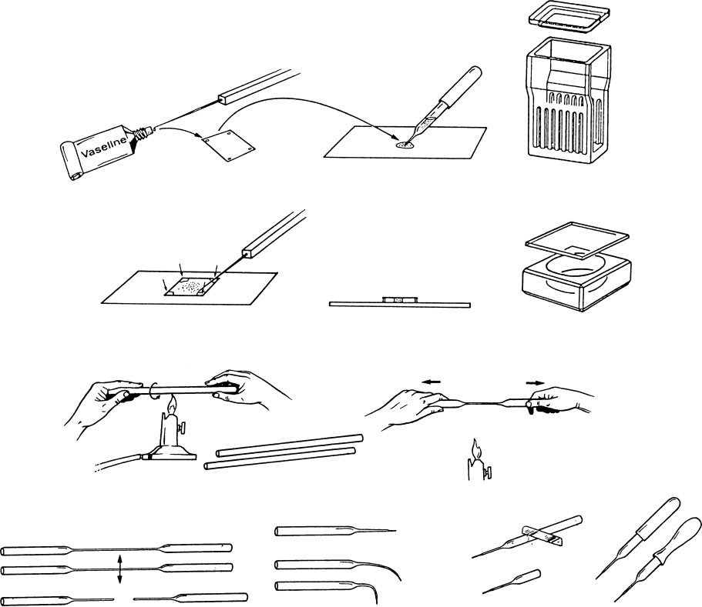
(
a
)
(
c
)
(
)
g
j
)
(
k
)
(
l
)
(
i
)
(
(
h
)
(
)
(
)
d
f
(
b
)
(
e
)
Fig. 1. (a–d) Preparation of slides for observing living ciliates (from Dragesco & Dragesco-Kerne´is 1986). (e) Staining jar for 8 and 16 (back to back) slides, respectively. (f) Watch-glass for the protargol procedure according to Wilbert (1975) and the cleaning of ciliates for scanning electron microscopy. (g–l) Making micropipettes (from Dragesco & Dragesco-Kerne´is, 1986).

Usually, silver impregnation is undertaken to reveal the infraciliature (5ciliary pattern) and the silverline pattern (5lines revealed by silver nitrate, connecting basal bodies and other cortical organelles such as extrusomes and the cytopyge). Extrusomes, various structures associated with the basal bodies of the cilia (e.g. parasomal sacs, microtubular ribbons) and several cortical fibrillar networks (e.g. the infraciliary lattice) are sometimes also impregnated. This may render interpretation of silver stains difficult. It is beyond the scope of this paper to discuss this problem in detail; in fact, interpretation is different for each method (and even for slight variations of each method) and almost for each higher systematic category. Thus, I must refer the reader to some key references (Foissner, 1977, 1981; G. Gelei, 1939; J. Gelei, 1934; Hiller, 1991; Hiller & Bardele, 1988; Klein, 1943; Peck, 1974; Tellez et al., 1982; Zagon, 1970). However, the differentiation of mono- and dikinetids must be mentioned because this is of basic importance for successful taxonomic work.
Cilia and their basal bodies may be arranged singly (monokinetids) or in pairs (dikinetids); the basal bodies may be ciliated or non-ciliated (e.g. Foissner & Foissner, 1988). All silver methods described here reveal at least the basal bodies (cilia are usually not impregnated with silver nitrate methods), but not each black or brown granule is a basal body of a cilium! Depending on the procedure used, other structures which have a similar size as the basal bodies are also impregnated (e.g. parasomal sacs, extrusomes). Thus, the arrangement and the state of the basal bodies cannot be unequivocally ascertained with silver methods, and transmission electron microscopy is necessary [scanning electron microscopy (SEM) is insufficient as it often does not reveal non-ciliated basal bodies]. The following procedure provides a rather reliable differentiation of mono- and dikinetids and of ciliated and non-ciliated basal bodies. (i) Study cells carefully in vivo, preferably with interference contrast. With some experience it is easy to see whether or not cilia are paired. (ii) Over-stain cells with protargol and/or silver carbonate. In over-impregnated cells cilia are usually clearly recognizable. (iii) Non-ciliated basal bodies and/or parasomal sacs are often slightly smaller than ciliated basal bodies. (iv) Study the electron microscopic literature related to the species or group of species under investigation and try to correlate the stained structures with ultrastructural features.

METHODS

Observing living ciliates
Many physical and chemical methods have been described for retarding the movement of ciliates in order to observe structural details (for literature, see Foissner, 1991). Chemical immobilization (e.g. nickel sulfate) or physical slowing down by increasing the viscosity of the medium (e.g. methyl cellulose) are, in our experience, usually unsuitable. These procedures often change the shape of the cell or cause premortal alterations of various cell structures. The following simple method is therefore preferable: place approximately 0.5 ml of the raw sample on a slide and pick out/collect the desired specimens with a micropipette (Fig. 1, g–l) under a compound microscope equipped with a low magnification (e.g. objective 4: 1, eyepiece 106). If specimens are large enough, they can be collected from a Petri dish under a dissecting microscope. Working with micropipettes, the diameter of which must be adjusted to the size of the specimens, requires some training. The collected specimens are now in a very small drop of fluid. Apply small dabs of petroleum jelly to each of the four corners of a coverslip or directly on the slide; it is useful to apply the jelly by an ordinary syringe with a thick needle. Place the coverslip on the droplet containing the ciliates. Press on the petroleum jelly corners with a mounted needle until the ciliates become slightly squeezed between the slide and the coverslip (Fig. 1, a–d). As the pressure is increased, the ciliates gradually become less mobile and more transparent. Hence, first the location of the main cell organelles (e.g. nuclear and oral apparatus, contractile vacuole) and then the details (e.g. extrusomes, micronucleus) can easily be observed under low (6100–400) and high (61000, oil immersion objective) magnifications.
The shape of the cells is of course altered by this procedure. Therefore, specimens taken directly from the sample with a large-bore pipette (opening ~1 mm) must first be investigated under low magnification (6100–400). Some species are too fragile to withstand handling with the micropipette and coverslip trapping without deterioration. Investigation with low magnification also requires some experience but it guarantees that undamaged cells are recorded. Video-microscopy is very useful at this point of investigation, especially for registering body shape and swimming behaviour.
A compound microscope equipped with differential interference contrast is best for observing living ciliates. If not available, use brightfield or phase-contrast; the latter is only useful for very flat species.
Staining Procedures
Although there are numerous methods for staining ciliates, most of the older procedures (e.g. haematoxylin; see Kirby, 1950 for an excellent compilation of protocols) have been outdated by silver impregnation techniques and electron microscopy. Various silver stains are available, but all need some experience and are usually individually modified. However, familiarity with the four silver methods described below is an absolute prerequisite for studying ciliates. These are thus described in great detail in order to give even beginners a fair chance to obtain usable slides.
Apart from silver impregnation, various other staining techniques are useful for taxonomic work with ciliates, especially the Feulgen nuclear reaction and supravital staining with methyl green-pyronin in order to reveal the nuclear apparatus and the mucocysts, respectively.
Simple, viz., molecular formulae are given for the chemicals used, since usually only these are found in the catalogues of the suppliers (e.g. Merck). In a laboratory manual it is thus convincing to use this style too, instead of the more correct constitutional or structural formulae.
Five plates of selected micrographs should show examples of excellent preparations. There are two ways to do this: either to use a few species
and show them treated with all methods described or to select many species to give the reader an impression of the diversity. I selected the second way as it is possibly more convincing for beginners. However, two species (Colpidium colpoda, Figs 2d, e, 6b, f and Paramecium caudatum, Figs 2g, h, 3a) are shown prepared with three methods and several others with two different methods.
- Feulgen nuclear reaction. Descriptions of this method can be found in Lee et al. (1985) and Dragesco & Dragesco-Kerne´is (1986). The Feulgen reaction reveals the nuclear apparatus very selectively. I use it only occasionally for a-taxonomic purposes because the nuclear apparatus usually stains well with protargol. However, as protargol often stains various small cytoplasmic inclusions too, some caution is necessary, especially with multimicronucleate species. If in doubt, use the Feulgen reaction or another nuclear staining method, such as that described by Larsen (1975).
- Supravital staining with methyl green-pyronin. This simple method is an excellent technique for revealing the mucocysts of many ciliates (however, those of tetrahymenids and rather many haptorids usually do not stain). Mucocysts are stained deeply and very selectively blue or red, and can be observed in various stages of swelling because the cells are not killed instantly. The nuclear apparatus is also stained. For examples see Fig. 2(i) in this paper and figures 8, 17 and 38 in Foissner (1991).
Procedure (after Foissner, 1979)
  - Pick out the desired ciliates with a micropipette and placethe very small drop of fluid in the centre of a slide.
  - Add an equally sized drop of methyl green-pyronin and mixthe two drops gently by swivelling the slide or with a needle. Remarks: If ciliates were already mounted under the coverslip, add a small drop of dye at one edge of the coverslip and pass it through the preparation with a piece of filter paper placed at the opposite end of the coverslip.
  - Place a coverslip with petroleum jelly corners on thepreparation and squeeze specimens slightly.
Remarks: Observe immediately. Cells die in the stain within seconds or minutes. Mucocysts stain very quickly and many can be observed at various stages of swelling. To reveal the nuclear apparatus, cells should be fairly strongly squashed (5flattened). The preparation is temporary. After 5–10 min the cytoplasm often becomes heavily stained and obscures other details.
Reagents
1 g methyl green-pyronin (CHROMA, Germany) distilled water to 100 ml and filter
Remarks: This solution is very stable and can be used for years

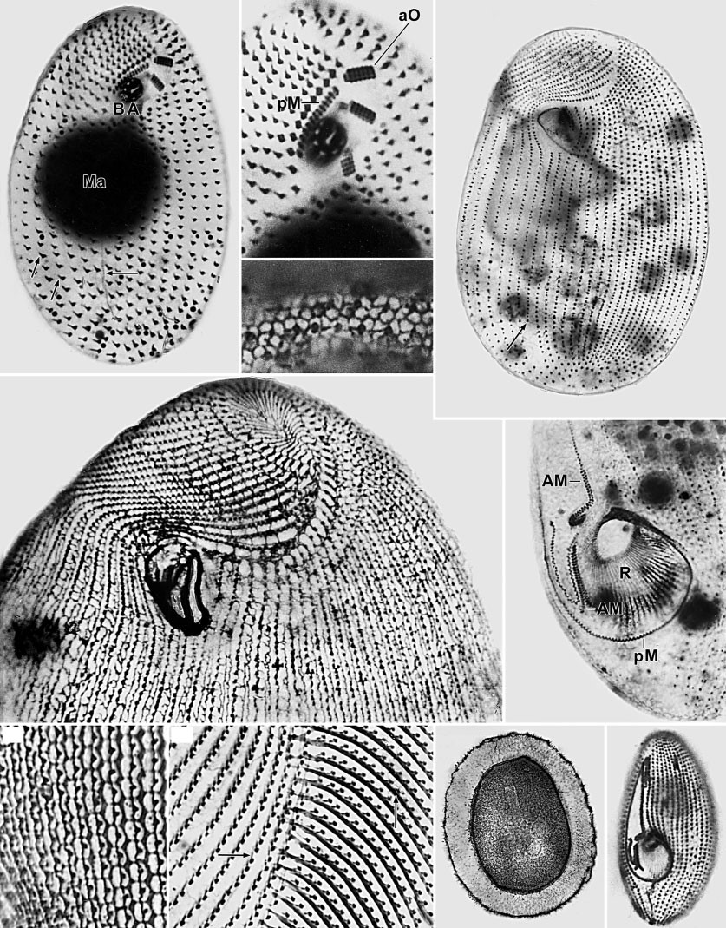
(
a
)
(
e
)
(
f
)
(
i
)
(
j
)
(
h
)
(
g
)
(
b
)
(
c
)
(
d
)

Fig. 2. Silver-impregnated ciliates (from Foissner, 1991). (a-c) Furgasonia blochmanni, infraciliature (a, b) and silverline pattern (c) of ventral side after silver carbonate (a, b) and wet silver nitrate impregnation (c), respectively. The oral basket (BA), the paroral membrane (pM), the adoral membranelles (aO), the macronucleus (Ma), the cytopyge (large arrow), and the kinetodesmal fibres (small arrows) are revealed with high clarity. (d, e) Colpidium colpoda, ciliary and silverline pattern of ventral side after protargol (d, Wilbert’s method) and dry silver nitrate (e) impregnation. Arrow marks a shortened ciliary row anterior of the cytopyge. (f, j) Pleuronema coronatum, ventral views after protargol (f, Wilbert’s method) and wet silver nitrate (j) impregnation. (f) shows the proximal portion of the oral apparatus where even single basal bodies within the adoral membranelles (AM) and the paroral membrane (pM) are recognizable; R, oral ribs. (g, h) Paramecium caudatum, silverline pattern after dry silver nitrate impregnation (g) and kinetodesmal fibres (arrows) after silver carbonate impregnation (h). (i) Obertrumia gracilis, a distinct mucocyst envelope becomes recognizable after addition of methyl green-pyronin.
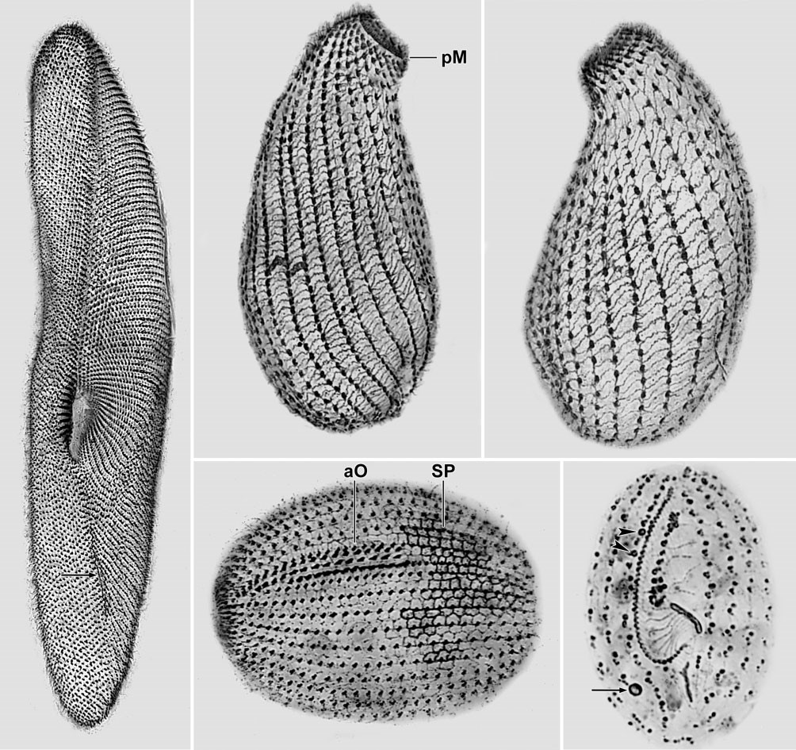
(
a
)
(
b
)
(
c
)
(
d
)
(
e
)
Fig. 3. Various ciliates impregnated with the ‘new’ wet silver nitrate method. (a) Paramecium caudatum, ventral view. Arrow marks cytopyge silverline. (b, c) Platyophryides latus, infraciliature and silverline pattern; pM, paroral membrane. (d) Pelagothrix sp. (anterior end is left), showing the ciliary pattern, the adoral organelles (aO) and the silverline pattern (SP). (e) Protocyclidium terricola, ventral view, showing the huge oral apparatus, the excretory pore of the contractile vacuole (arrow) and docked extrusomes (arrowheads).

- The ‘dry’ silver nitrate methods. Because of the numerous problems with the basic dry Klein (1926, 1958) technique, Foissner (1976) and others (e.g. J. Gelei, 1934; Ruzicka, 1966) introduced some improvements. The dry methods (‘dry’ because cells are air-dried and not chemically fixed before being treated with silver nitrate) provide preliminary information on the somatic and oral infraciliature (5ciliary pattern) and are often best for revealing the silverline pattern (5lines revealed by silver nitrate and connecting basal bodies and other cortical organelles such as extrusomes and the cytopyge). Although the results vary highly, the method is worthwhile because it is quick and often produces excellent preparations, which can be well-documented since the cells are flattened during dehydration. Only cortical structures are revealed. For examples see Fig. 2(g) in this paper and figures 15, 19, 20, 23, 26, 35 and 36 in Foissner (1991). Procedure (after Foissner, 1976 and recent experience)
  - Take 5–10 clean slides and spread a very thin layer ofalbumin over the middle third of each with a fingertip. Dry for at least 1 min.
Remarks: The egg-albumin (remove germinal disc! do not add glycerol) must have been kept open in a widenecked flask for at least 20 h; fresh albumin is often less

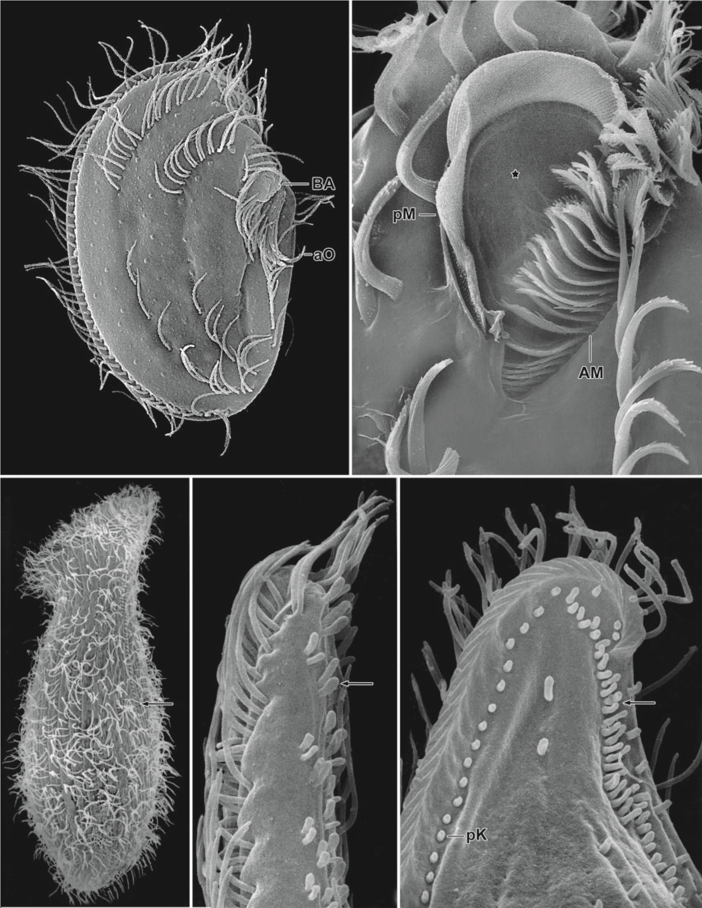
(
a
)
(
b
)
(
e
)
(
d
)
(
c
)

Fig. 4. Various ciliates in the scanning electron microscope (a, from Foissner et al., 2011; b, from Foissner & Al-Rasheid, 2006; c-d, from Foissner, 1991). (a) Leptopharynx costatus, ciliary pattern of right and ventral side. The distal end of the oral basket (BA) and the ciliary bundle of the adoral organelles (aO) are recognizable. (b) Cyrtohymena candens, oral apparatus, showing the huge paroral membrane (pM), the adoral membranelles (AM) and the buccal seal (asterisk) which is a membrane that closes the deep buccal cavity. (c) Spathidium spathula, left side view showing the minute cilia associated with row 3 of the dorsal brush (arrow). (d, e) Rimaleptus mucronatus (d) and Litonotus lamella (e), left side views of distal body portion. The specialized cilia of the brush (arrows), the perioral kinety (pK) and other details can be revealed with such clarity only by scanning electron microscopy. The images are from environmental material cleaned with the method described.
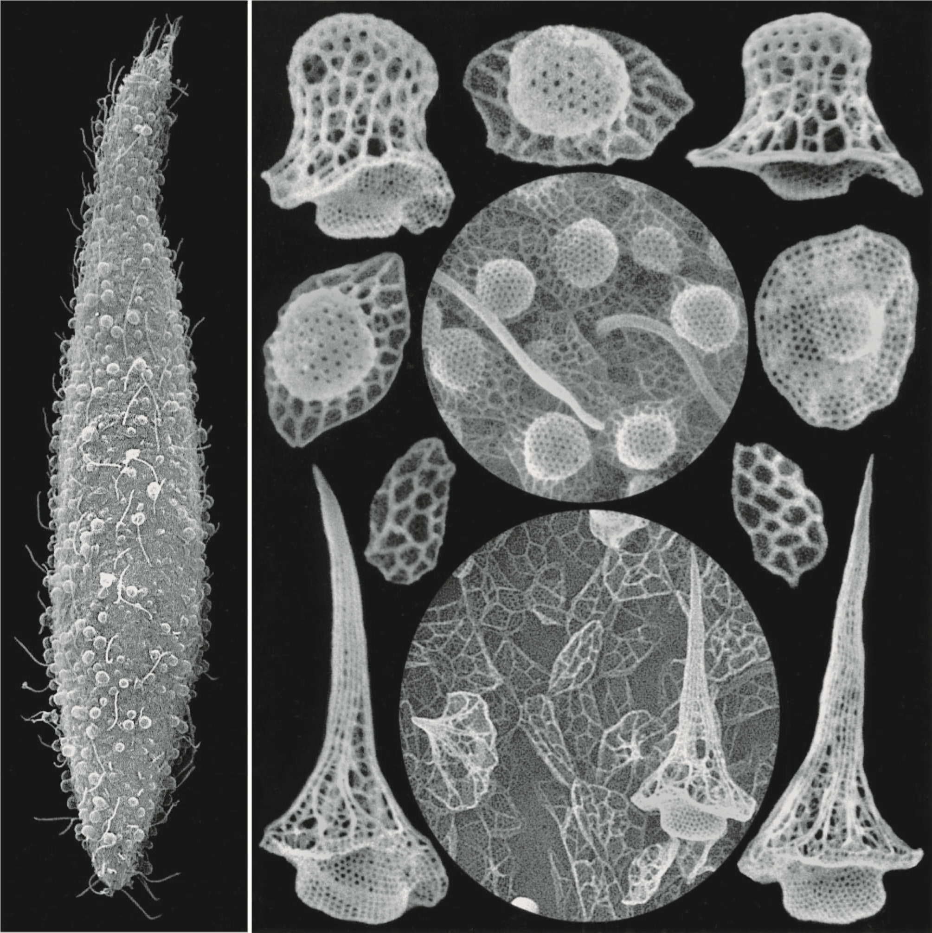
(
a
)
(
b
)

Fig. 5. Sleighophrys pustulata (a, b) and Luporinophrys micelae (b) in the scanning electron microscope (from Foissner, 2005). These species have highly fragile epicortical scales (lepidosomes) well preserved by the method described. Sleighophrys has hat-shaped lepidosomes while those of Luporinophrys are up to 10 mm high cones; and both have ellipsoidal, widely meshed base plates.

satisfactory. It can be used for 2–3 days if the flask is subsequently sealed; however, do not stir before use, but skim the albumin from the surface with a fingertip. To facilitate spreading, breathe on the slide so that a film of condensation is produced on which the albumin can glide. The albumin layer must be very thin and uniform but should not cover the cells.
- Place a drop of fluid containing the ciliates on the albumizedslide, spread with a needle (do not touch albumin layer!), and dry the preparation at room temperature.
Remarks: Even single specimens can be placed on the albumized slide with a micropipette. If necessary enrich ciliates by gentle centrifugation or by leaving the sample to settle for a few hours, after which time oxygen depletion induces many ciliates to move to the water surface. The amount and chemical composition of the fluid with which the ciliates are air-dried, as well as temperature and air humidity, greatly influence the results. Therefore, 5–10 slides should usually be prepared simultaneously to vary these parameters, e.g. by washing

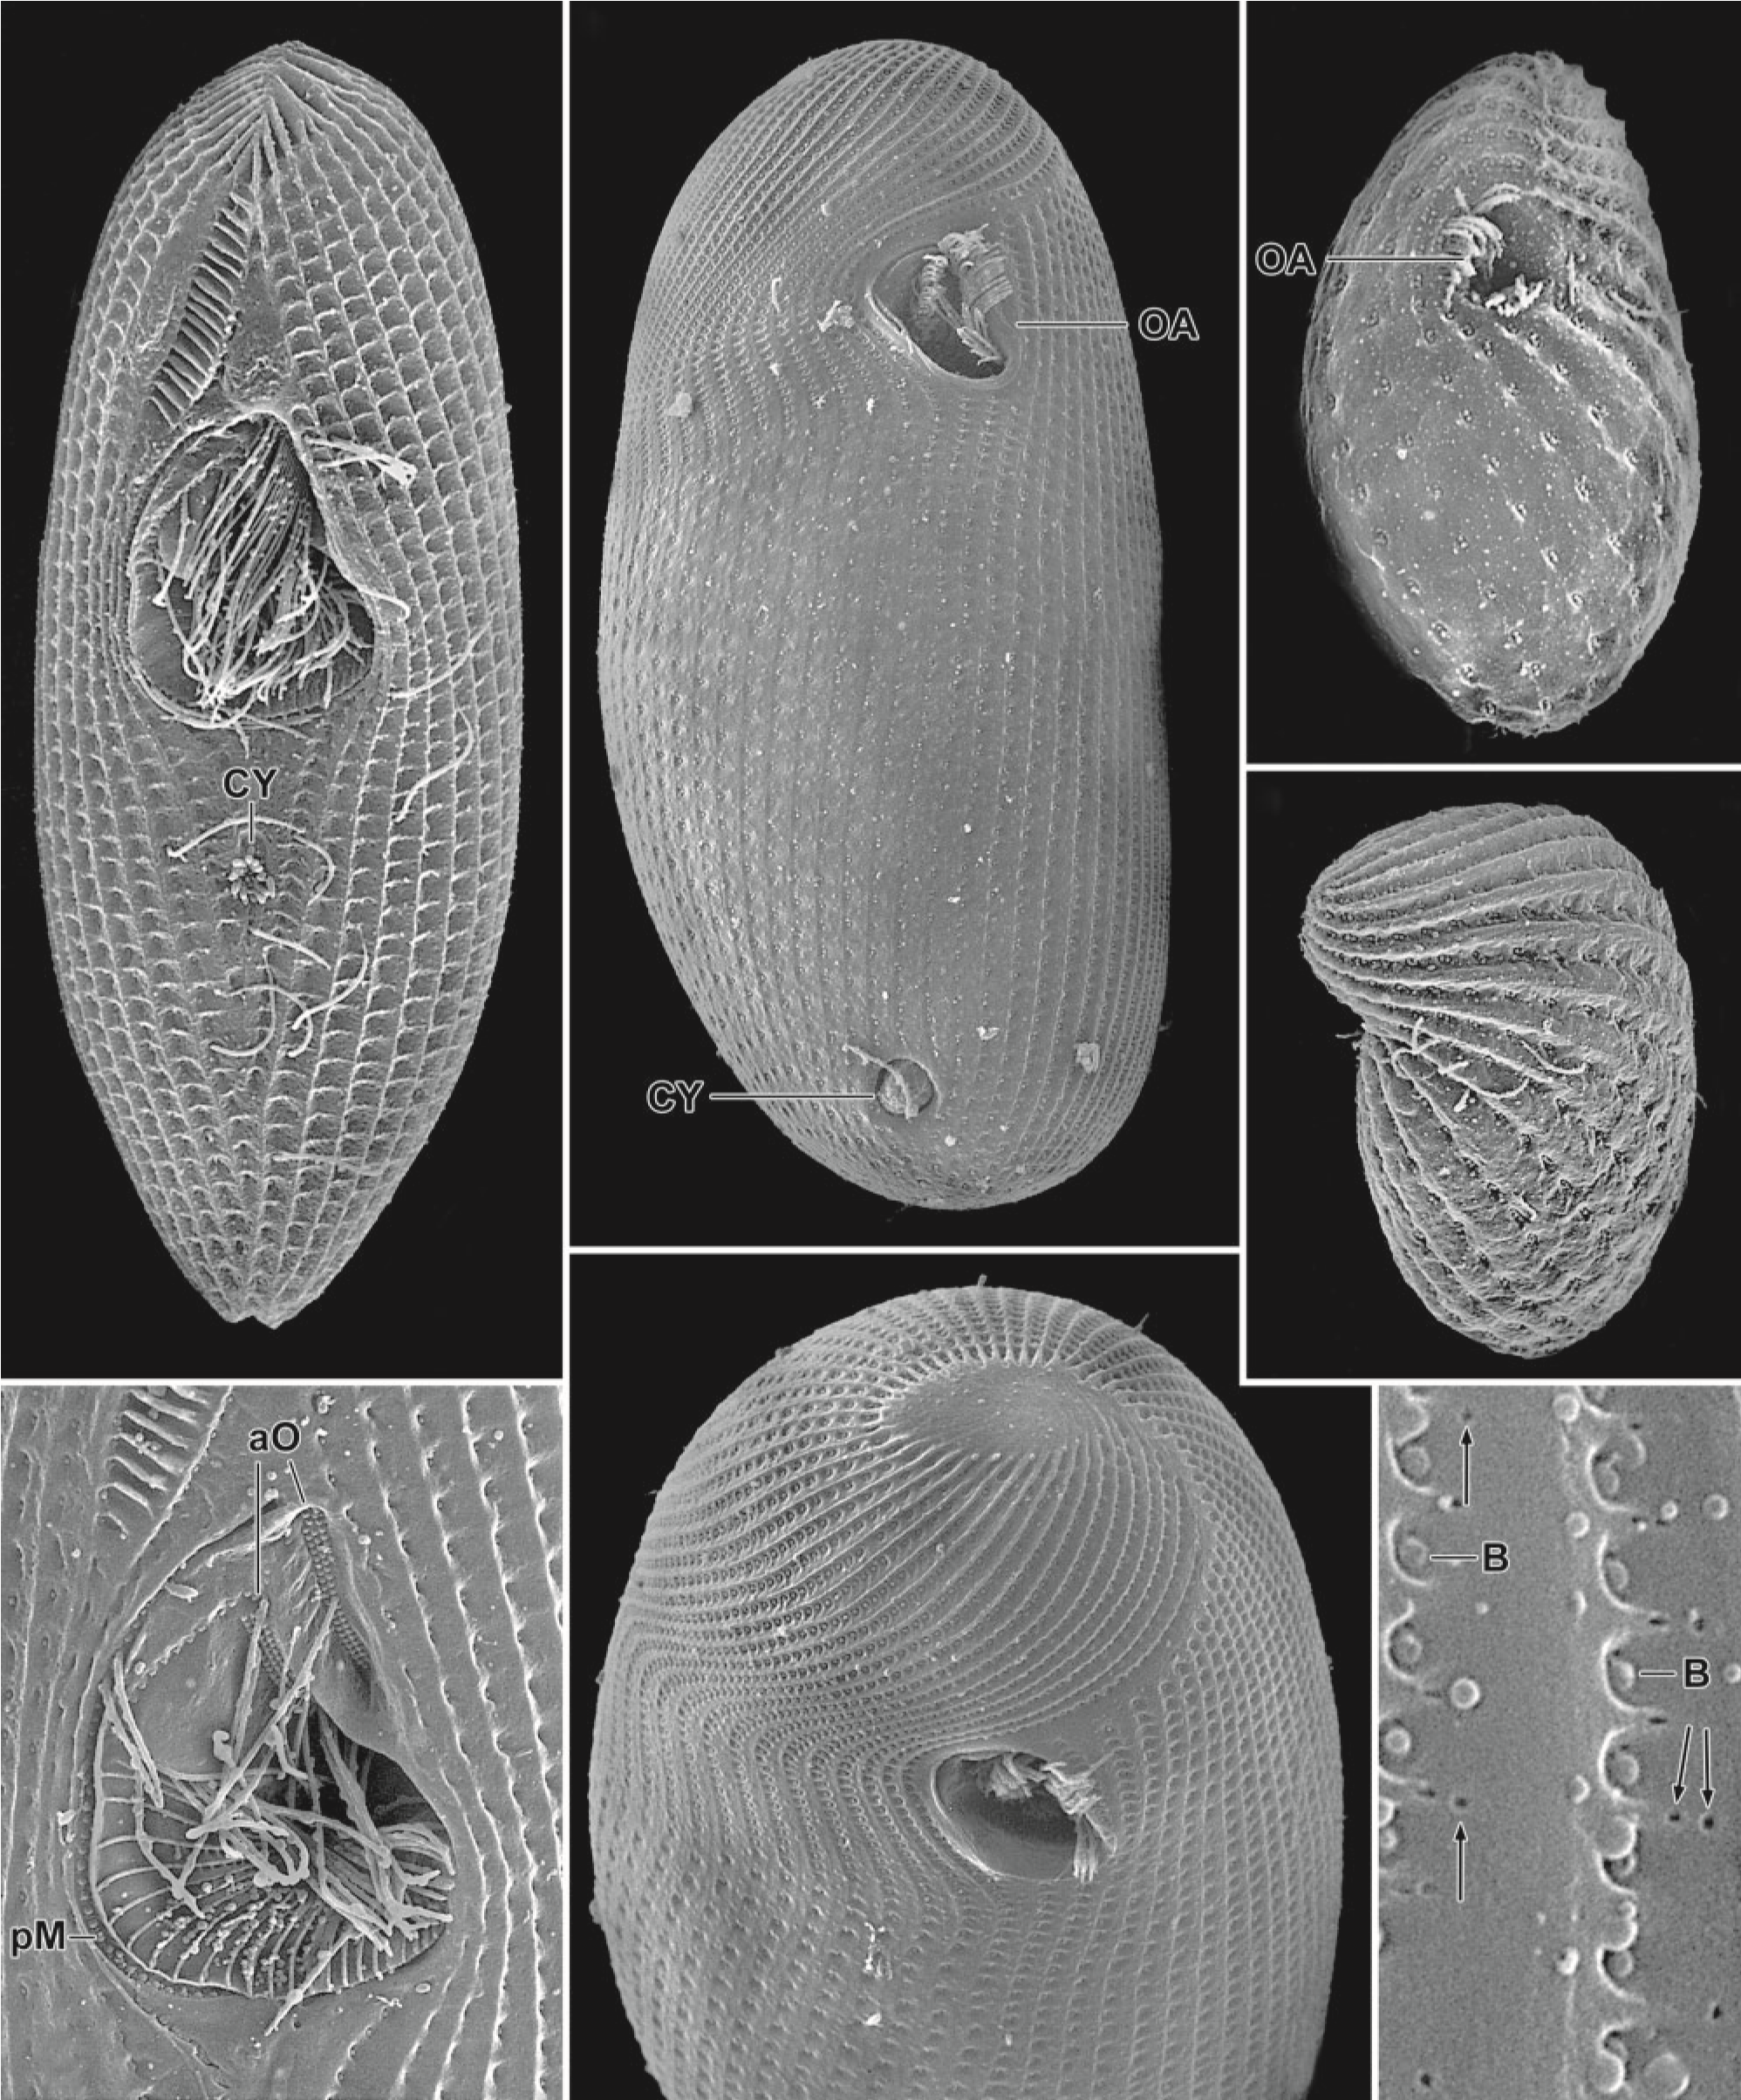
(
a
)
(
b
)
(
c
)
(
d
)
(
f
)
(
e
)
(
g
)
Fig. 6. Ciliates deciliated with liquid soap (Teepol). (a, g) Sathrophilus sp. has a complex cortex and oral apparatus both clearly recognizable in deciliated specimens. aO, adoral organelles; CY, cytopyge; pM, paroral membrane. (b, f) (see also Fig. 2, d–e) Colpidium colpoda, ventral and anterior polar view, showing the arrangement of the ciliary rows, especially the complex pole pattern; the oral apparatus (OA); and the cytopyge (CY) which just releases faecal mass. (c, d) Colpoda maupasi, ventral and dorsolateral view, showing the oral apparatus (OA) and distinct ridges between the ciliary rows. (g) Glaucomides bromelicola (from Foissner, 2013), showing two ciliary rows, their basal bodies (B) and minute openings in the cortex (arrows) where extrusomes will be released.

cells with different amounts of distilled water or fresh culture medium. Washing cells with distilled water or spreading the drop to a very thin film is especially recommended with saline fluids, e.g. seawater, sewage and soil. Temperature and humidity are varied using an ordinary hairdryer.
- Apply some drops of silver nitrate to the dried material forabout 1 min.
Remarks: Do not touch albumin layer with the pipette. The reaction time does not influence the results; a minute is adequate to impregnate and fix the cells on the slide.
- Wash the slide for about 3 s with distilled water and redry.Remarks: Wash gently! Apply water current from the top third of the tilted slide so that water runs gently over the dried material. Leave slide tilted during drying.
- Pre-develop the dried slide by exposing it for 5–60 s to a40–60 W electric bulb at a distance of 3–10 cm. Remarks: Time and distance influence intensity of impregnation (see also next step).
- Apply a few drops of developer to the dried preparation forabout 60 s.
Remarks: The pre-development (step 5), the composition of the developer, and the material itself influence impregnation intensity and quality. The best ratio of these parameters must be evaluated in pilot experiments. If the developer is well-adjusted, the albumin around the dried fluid turns brown-black; if the developer is too strong, the albumin appears black (add some component A [see Reagents] and/or reduce pre-developing time); if the developer is too weak, the albumin appears brownish or yellowish (add some components B and/or C and/or increase pre-development time).
- Pour developer off slide, rinse gently in tap water for 5–10 s, and immerse it in the fixative (sodium thiosulfate) for 5 min.
- Remove slide from fixative and rinse gently in tap water for10 min changing the water three times.
Remarks: The fixative must be thoroughly removed to avoid bleaching of the impregnation. Preparations usually fade within a few weeks when the silver nitrate is reduced only by sunlight or an UV-lamp. Do not use distilled water, otherwise cells swell and eventually detach from the slide!
- Air-dry the slide again and mount in synthetic neutralmedium (e.g. Eukitt, Euparal).
Remarks: Slides should be tilted during drying. Mounting medium should be of medium viscosity. The preparation is stable, providing good fixation and careful elimination of the fixative.
Reagents
- Silver nitrate solution (long-term stability in brown flask)1 g silver nitrate (AgN0₃) distilled water to 100 ml
- Developer (stable for about 1–3 days; must be renewed assoon as it turns dark brown or shows crystals; mix components in the sequence indicated)
20 ml solution A
1 ml solution B
1 ml solution C
Solution A (this is an ordinary developer for negatives; dissolve ingredients in the sequence indicated; stable for a year in brown bottle)
1000 ml hot tap water (about 40 uC)
10 g boric acid (H₃B0₃)
10 g borax (Na₂B₄0–)
5 g hydroquinone (C₆H₆O₂)
100 g anhydrous sodium sulfite (Na₂SO₃) 2.5 gmetol5methylamino-phenol-sulfate5(CH₃NHC₆H₄OH)₂.
H2SO4
Solution B (this is a concentrated photographic paper developer; dissolve ingredients in the sequence indicated; stable for about 6 months when stored in fully filled cups)
100 ml distilled water
0.4 gmetol5methylamino-phenol-sulfate5(CH₃NHC₆H₄OH)₂. H2SO4
5.2 g anhydrous sodium sulfite (Na₂SO₃)
1.2 g hydroquinone (C₆H₆O₂)
10.4 g sodium carbonate (Na₂CO₃)
10.4 g potassium carbonate (K₂CO₃)
0.4 g potassium bromide (KBr) Solution C (stable for several years) 10 g sodium hydroxide (NaOH) distilled water to 100 ml
- Fixative for impregnation (stable for years)
50 g sodium thiosulfate (Na₂S₂O₃. 5H₂O) distilled water 1000 ml
- The ‘wet’ silver nitrate methods. The first wet (‘wet’ because cells are chemically fixed before being treated with silver nitrate) method was described by Chatton & Lwoff (1930, 1936). The technique became well-known after Corliss (1953) published the version in use in the Paris laboratory of Faure´-Fremiet. It works well with many kinds of limnetic and marine ciliates, especially with hymenostomes (e.g. Tetrahymena, Paramecium, Cyclidium), holophryids (e.g. Holophrya), most colpodids (e.g. Colpoda, Bresslauides) and some hypotrichs (e.g. Euplotes). Less convincing results are usually obtained with peritrichs (e.g. Vorticella), heterotrichs (e.g. Spirostomum, Metopus), oligotrichs (e.g. Halteria) and most hypotrichs (e.g. Oxytricha, Urostyla). The wet methods provide valuable information on the somatic and oral infraciliature as well as the silverlines, which are, however, often rather faintly stained. The shape of the cells is usually well-preserved, which is of advantage to the investigation but makes photographic documentation difficult. As with the dry methods, only cortical structures are revealed. For examples see Figs 2(j) and 3 in this paper and figures 7, 10, 16, 28 and 29 in Foissner (1991). Modifications have been described by for example Chatton (1940), Frankel & Heckmann (1968), Lynn et al. (1981) and Roberts & Causton (1988), who investigated some variables in detail.
The method described in 1991 and likely all modifications have several problems: (i) the gelatin, in which the specimens are embedded, is too weak, i.e. does not become sufficiently solid, and the preparations are lost or full of clouds; (ii) the gelatin becomes cloudy and/or gets sharp fissures above the individual cells, even if ‘good’ gelatin is used; (iii) the impregnation is too faint, especially on the ‘back side’, that is the side oriented to the microscope slide; and (iv) the impregnation bleaches more or less strongly within a few days or months.
Problem (i) can be solved by using ‘Gelatin, from Bovine Bone’ (Wako, Japan). Problem (ii) occurs when the preparation becomes too warm, i.e. when the gelatin commences melting. Thus, keep the preparation ,10 uC throughout the procedure. Problem (iii) is partially caused by the inability of UV-light to penetrate sufficiently the gelatin and the cells. Thus, silver reduction must be done from above and below (see step 12) and chemical development should follow UV-reduction. The fourth problem, I solved only recently (see steps 13–15). It makes the protocol rather complex but is worth doing because stable preparations can be obtained. Several slides should be prepared simultaneously from the same material. If only a few specimens are available, these must be handled with micropipettes during steps 1–7 (difficult task!); for ample material a centrifuge may be used. Until dehydration (step 19), keep all solutions cold (,10 uC) as warming causes clouds or even detaches the gelatin from the slide. The Da Fano solution is of paramount significance because it determines the strength of the impregnation. If too much is used, precipitations may develop; if too little is used, the impregnation may become too faint. The method is not simple and requires experience. Since some steps must be done quickly, it is necessary to be well-organized. Procedure
      - If possible, concentrate ciliates by gentle centrifugation (thefixative is expensive) or collect individual specimens and drop them into the fixative.
      - Put ciliates into Champy’s fluid and fix for 1–30 min.Remarks: The ratio of material to fixative should be at least 1 :1, better 1 : 2. The fixation time apparently does not influence the results greatly. We usually fix for about 10 min. Fixation should be carried out in a fume hood since osmic vapours are highly toxic.
      - Remove fixative by centrifugation or micropipette andpost-fix in Da Fano’s fluid for at least 5 min. Continue this replacement until the solution is the colour of Da Fano’s fluid (2–3 times are usually enough). Remarks: Material can be stored in Da Fano’s fluid for years.
      - Place a very clean, grease-free slide on a hotplate (35–60 uC).
Remarks: The slides must be grease-free (clean with alcohol and flame); even commercially pre-cleaned slides should be cleaned with an alcohol-moist cloth.
      - Place a small piece (about 2–4 mm diameter) of gelatin inthe centre of the warmed slide and allow to melt.
Remarks: Gelatin should have been stored in the refrigerator for at least one week before use. Fresh gelatin may cause cloudy silver deposits.
      - Quickly add an equal-sized or smaller drop of concentratedspecimens to the molten gelatin and remove slide from hotplate.
Remarks: Use the least amount of Da Fano’s fluid as possible. Mix organisms thoroughly into the gelatin using a mounted needle.
      - Quickly spread the drop on the slide or remove excess fluidunder the dissecting microscope with a warmed micropipette until ciliates remain just nicely embedded in a thin gelatin layer.
Remarks: Steps 6 and 7 must be done quickly to avoid hardening and/or desiccation of the gelatin; if gelatin solidifies during the procedure return the slide to the hotplate for a few seconds. Excess fluid can be removed only if ciliates are large or very numerous. For small (,100 mm) species, and in general, it is more convenient to spread the drop over the slide until the gelatin layer has the appropriate thickness. If the drop does not spread well, the slide is not grease-free. The gelatin layer must be thin to allow the silver nitrate and UV-light to pass through. Material should be very concentrated; if too much Da Fano’s fluid has been used or remains, precipitations develop or the gelatin detaches.
      - Immediately transfer the slide to a cold, moist chamber (e.g.a covered Petri dish with damp filter paper covering the bottom). Leave for about 5 min in the refrigerator or on ice until the gelatin has hardened.
Remarks: The gelatin must be hardened (check with tip of a mounted needle under dissecting microscope if in doubt) but must not desiccate and/or freeze. Desiccated or frozen slides are of poor quality.
      - Flush slide in cold distilled water for 3–10 s.Remarks: This step is essential and determines the quality and intensity of the impregnation. If the preparation is washed for too long, the impregnation may become too faint; if it is insufficiently washed, coarse silver precipitations may cover the gelatin. It is recommended that at least four slides, washed for 3, 5, 7 and 10 s, respectively, are prepared.
      - Immediately transfer slide to cold silver nitrate solution for30–60 min.
Remarks: Keep silver nitrate solution cold, as warming melts and detaches the gelatin from the slides. 30 min impregnation suffices for large ciliates (e.g. Paramecium). Immersion of more than 60 min intensifies impregnation only slightly and may cause darkening of cytoplasmic inclusions. The gelatin layer becomes slightly milky in the silver nitrate solution. A distinct milky coat indicates that too much Da Fano’s fluid has been used and/or remained (step 7).
      - Flush slides with cold distilled water for 1 min.
      - Immediately submerge slides into ~2 cm depth cold distilled water. Irradiate slides for 30 min each from above and below to obtain fully impregnated cells, using UV sources (,254 nm) placed 5–15 cm above and below the slides until the gelatin turns golden brown.
Remarks: Tilt dish gently back and forth and change water after 2–3 min of irradiation to avoid silver precipitations. Take care that water remains cold (,10 uC).
      - After UV-irradiation, place slides in cold ordinary protargoldeveloper diluted 1: 1 with distilled water for 15 min.
      - Wash slides in cold distilled water for 3 min.
      - Immerse slides for 5 min in the cold silver fixer (sodiumthiosulfate) used for protargol impregnation.
      - Wash slides five times in cold distilled water for about 10 h;keep the preparation cool in the refrigerator.
Remarks: Washing out all chemicals is of paramount significance for stabilizing the preparation.
      - Transfer slides to chilled 30% and then 70% alcohol(ethanol) for 10 min each.
      - Complete dehydration by two transfers at least 10 min longthrough 100 % alcohol (ethanol) at room temperature.
Remarks: As the gelatin hardens, the alcohol does not need to be chilled. Dehydrate thoroughly to avoid milky ‘water spots’ in the mounted slides.
      - Clear by two transfers of at least 10 min through xylene.Remarks: A prolonged stay in xylene (e.g. 2 days) sometimes produces extremely clear preparations.
      - Mount in synthetic neutral medium.
Remarks: Do not dry slides between steps 19 and 20! The mounting medium should be rather viscous to avoid airbubbles being formed when the solvent evaporates during drying. If air-bubbles develop in the mounted and hardened slide, reimmerse in xylene for some days until the coverslip drops off. Remount using a more viscous medium and remove materials protruding from the gelatin. Usually, some air bubbles are found immediately after mounting; these can be pushed to the edge of the coverslip with a finger or mounted needle. The preparation is stable. However, the drop margin may bleach more or less. The infraciliature should stand out dark brown or black against the light brown gelatin and the unstained cytoplasm. Silver deposits on the gelatin surface indicate that too much Da Fano’s fluid remained (steps 7–9).
Reagents
a) Champy’s fixative (prepare shortly before use; 9 ml of the fluid will usually suffice for one or two fixations; use fume hood)
7 parts (3.5 ml) 1 % aqueous chromic acid (CrO₃)
7 parts (3.5 ml) 3% aqueous potassium dichromate
(K₂Cr₂O₇)
4 parts (2.0 ml) 2 % aqueous osmium tetroxide (OsO₄) b) Da Fano’s fluid (stable for years; large amounts can thus be prepared)
900 ml distilled water (or seawater, without additional
NaCl, for marine ciliates)
10 g cobalt nitrate (Co(NO₃)₂ .6H₂O) 100 ml formalin (HCHO; commercial concentration, about 37%)
10 g sodium chloride (NaCl)
c) Gelatin (may be used as long as not colonized by bacteria or fungi; the molten gelatin must be clear and slightly yellowish; use a high-quality product!)
10 g powdered gelatin
0.1 g sodium chloride (NaCl)
100 ml distilled water
Remarks: Mix these components and melt gelatin in a waterbath, stirring frequently. Pour mixture into small, sterile cups and store in the refrigerator. Filled cups can be used for years.
d) Silver nitrate solution (may be used for several preparations, i.e. for about 40 slides if these are made on the same day; used solutions older than 1 day may cause problems)
3 g silver nitrate (AgNO₃) distilled water to 100 ml
The following materials must be prepared on the day preceding the preparation:
        - Salinated gelatin
        - Osmium tetroxide (takes about 10 h to dissolve)
        - Chill a moist chamber i.e. a large Petri dish (step 8);the reduction dish (step 12); the silver nitrate solution; distilled water; the chemical developer and fixer; and alcohol (30% and 70%) in appropriate amounts
- The silver carbonate methods. Because of the large quantity of cells needed for the basic Ferna´ndez-Galiano (1976) technique, Augustin et al. (1984) proposed a modification which requires only few specimens and may also yield permanent slides. Although the results are highly variable with all modifications, the method is worthwhile because it works very fast and often produces excellent impregnations, especially with hymenostomes (e.g. Tetrahymena, Paramecium), holophryids (e.g. Holophrya), colpodids (e.g. Colpoda, Bryometopus, Platyophrya) and heterotrichs (e.g. Stentor). Fixation is by formalin, which means that the shape of the cells is poorly preserved and even destroyed (cells burst) in some species (e.g. most hypotrichs). The cells swell strongly during the preparation process and become very soft being easily flattened between slide and coverslip. This makes photographic documentation easy but may result in interpretation errors. The silver carbonate methods reveal the infraciliature and certain cortical and cytoplasmic structures, especially the kinetodesmal fibres and the nuclear apparatus. The silverlines in most cases do not stain. Several modifications have been suggested (Wilbert, 1983; Wolska, 1966). Ma et al. (2003) provide a protocol for marine ciliates. Independently, I developed the same protocol and can state that it works well. However, permanent preparations loose quality, as with the Augustin method (see step 5). For examples see Fig. 2(a, b, h) in this paper and figures 5–6, 11, 18 and 27 in Foissner (1991).
Procedure (after Augustin, Foissner and Adam, 1984)
    - Place a droplet (about 0.05 ml or less) of a rich ciliateculture or even single specimens on a slide.
Remarks: Slide need not be grease-free. The middle-third should be delimited by lines drawn with a greasy fingertip or a wax crayon to prevent solutions from spreading over the whole slide.
    - Add 1–2 drops of formalin (about 4%) and fix for 1–3 min.Mix organisms with formalin by swivelling the slide. Remarks: The duration of this step may greatly influence the results. Species with a firm cortex (or resting cysts) usually need to be fixed longer (¢3 min) than those with a more fragile cortex (¡1 min). Some species cannot be fixed well with formalin and cells may even burst. For these species, fixation with osmium tetroxide vapours is sometimes useful (place inverted slide with ciliates over a 4% osmium tetroxide solution in a fume hood for about 1 min). Fix as usual with formalin after osmium treatment.
    - Add 1–3 drops of Ferna´ndez-Galiano’s fluid to the fixed ciliates, without washing out the formalin, and mix by swivelling the slide for 10–60 s.
Remarks: The amount of Ferna´ndez-Galiano’s fluid needed depends on many unpredictable factors (e.g. amount and concentration of fixative, size of drops, kind of species and composition of sample fluid). 1–3 drops usually work well. The same holds for the reaction time (10–60 s). The trial and error method must frequently be used to obtain best results!
    - Place slide on a preheated (60–70 uC) hotplate and leave until the drop, which is now rather large, turns golden brown (like cognac). This usually takes 2–4 min and the slide must be kept in constant circular motion during this time. As soon as the drop appears cognac-coloured, check impregnation with the compound microscope. Replace the slide on the hotplate if the impregnation is still too faint; if it is already too dark repeat the procedure, starting with step 1, but vary amount of Ferna´ndez-Galiano’s solution and/or impregnation time etc. If the preparation is too faint, specimens can be put on a new slide and the procedure repeated beginning with step 2.
Remarks: The correct impregnation time depends on many factors which are difficult to control (size of drops, temperature, kind of species, etc). The ratio of the components in the Ferna´ndez-Galiano fluid is especially important. Add, e.g. some drops of pyridine and/or silver carbonate solution to the Ferna´ndez-Galiano fluid if the impregnation is repeatedly too faint, i.e. cannot be intensified by prolonged heating. Fix ciliates in 2–3 drops of formalin instead of 1–2 drops if impregnation is too faint. Ciliates from old cultures, ion-rich fluids (e.g. sewage, soil) or anaerobic biotopes frequently impregnate poorly. For these, impregnation sometimes improves if they are washed prior to fixation (fluid from sample and distilled water 1:1).
    - Interrupt impregnation by removing the slide from thehotplate and adding a drop of fixative (sodium thiosulfate). Remarks: The preparation is now ready. Augustin et al. (1984) describe a method for obtaining permanent slides. Their quality is, however, often not as good as with wet (fresh) preparations, which are thus usually preferred for investigation and photography. Pick out some well impregnated specimens with a micropipette, place them on a clean slide and cover with a coverslip. For good pictures, the drop with the selected specimens should be very small so that cells are compressed between the slide and the coverslip. Excess fluid may be removed from the edge of the coverslip using a piece of filter paper. The impregnation need not be fixed with sodium thiosulfate if the investigation is undertaken immediately. The impregnation is stable for some hours when stored in a moist chamber. I recommend that the cells be compressed between the slide and coverslip immediately after the impregnation since silver precipitates may occur with time in the reaction fluid.
Reagents
      - Fixative for organisms (stable for a long time)0.2 ml formalin (HCHO; commercial concentration, about 37%) distilled water to 10 ml
      - Ferna´ndez-Galiano’s fluid (prepare immediately before use; components can be stored and must be mixed in the sequence indicated. The mixture must be slightly milky. If stored in a brown flask, it can be used for some hours. Keep away from sunlight. Make up fresh fluid when no more impregnation can be achieved)
0.3 ml pyridine (C₅H₅N; commercial concentration)
2–4 ml Rio-Hortega ammoniacal silver carbonate solution
0.8 ml proteose-peptone solution 16 ml distilled water
c) Fixative for impregnation (stable for years)
5 g sodium thiosulfate (Na₂S₂O₃) distilled water to 100 ml
      - Rio-Hortega ammoniacal silver carbonate solution. Preparation (the ratios are important!): place 50 ml of a 10 % aqueous silver nitrate solution in a flask; add 150 ml of a 5 % aqueous sodium carbonate (Na₂CO₃) solution little by little under constant stirring; add 25 % ammonia (NH₃), drop by drop, until the precipitate dissolves, being careful not to add an excess; finally add distilled water up to a total volume of 750 ml. The solution is stable for
years
      - Proteose-peptone solution (long-term stability if not
colonized by bacteria and/or fungi; discard dull solutions)
96 ml distilled water
4 g proteose-peptone (bacteriological; sprinkle powder on the surface of the water and allow to dissolve without
stirring)
0.5 ml formalin (HCHO in commercial concentration; for preservation)
- Protargol methods. Protargol methods are indispensable for descriptive research on ciliates. The first protocols were provided by Kirby (1945), Moskowitz (1950), Dragesco (1962) and Tuffrau (1964, 1967), and many more modifications were subsequently proposed (Aufderheide, 1982; Dieckmann, 1995; Dragesco & Dragesco-Kerne´is, 1986; McCoy, 1974; Ng & Nelsen, 1977; Wilbert, 1975, 1976; Zagon, 1970). Protocols for quantitative protargol stains (QPS) have been published by, for example, Montagnes & Lynn (1987) and Skibbe (1994). Here, three qualitative variations which produce good results in our laboratory are described. These protocols work well with most ciliate species (some, however, only rarely impregnate well, e.g. Loxodes, Paramecium) but require at least 20 specimens. Contrary to the silver carbonate method, single specimens cannot usually be handled successfully. Depending on the procedure used, protargol can reveal many cortical and internal structures, such as basal bodies, cilia, various fibrillar systems, and the nuclear apparatus. The silverlines, however, never impregnate. The shape of the cells is usually well-preserved in permanent slides, which is an advantage for the investigation but makes photographic documentation more difficult. However, pictures as clear as those taken from wet silver carbonate impregnations can be obtained with the Wilbert modification if the cells are photographed prior to embedding in the albumin glycerol. This applies also to my protocol (see step 12).
The more recent preparations are done with the method described now. It differs from my 1991 protocol in some small but important details: instead of using distilled water, tap water is used in most steps. This avoids swelling and detachment of the albumin, the main problem in the 1991 protocol. In addition, ‘new’ fixatives and a second developer, which produces more contrast, are introduced.
The quality of the slides is usually adequate but frequently not as good as with the Wilbert modification. The latter demands more material and experience; inexperienced workers may easily lose the material. As in all protargol methods, the procedure is rather time-consuming and complicated. Experiments with students showed that beginners have a fair chance of obtaining good slides (for example, figure 31 in Foissner 1991). A centrifuge may be used for step 2; staining jars (Fig. 1e) are necessary for steps 6–16. The procedure is complex and subject to many factors. Thus, be well-organized and study ‘Remarks’ carefully. For examples see procedure B.
Procedure A
    - Fix organisms in Bouin’s or Stieve’s fluid or in alcohol (50–100 % depending on species and material), alcohol/formalin solution (see below), formalin (~4%), or in other fixatives for 10–30 min.
Remarks: To use an appropriate fixative is of paramount significance. Surprisingly, simple alcohol frequently provides excellent impregnations, although shrinkage may be rather pronounced. Alcohol/formalin and Champy’s or Da Fano’s fixatives are sometimes also useful. The fixation time has little influence on the quality of the preparation within the limits given. The ratio of fixative to sample fluid should be at least 1 :1. Pour ciliates into the fixative, using a wide-necked dish to bring the organisms in contact with the fixative as fast as possible. Most fixatives may be supplemented with some drops of 2 % osmium tetroxide for better fixation of fragile ciliates, e.g. the hypotrich Urosoma, which, however, fixes perfectly with alcohol. This increases the stability of the cells but usually reduces their impregnability.
    - Concentrate specimens by centrifugation and wash 3–4 times in tap water.
Remarks: There are now two choices: either continue with step 3 or transfer the material through 30–50–70 % alcohol (ethanol) where it remains stable for years. Transfer preserved material back through the graded alcohol series into tap water prior to continuing with the next step. The impregnability of preserved material may be slightly different.
    - Clean eight slides (or less if material is very scarce) persample. The slides must be grease-free (clean with alcohol and flame or use pre-cleaned slides).
Remarks: Insufficiently cleaned slides may cause the albumin to detach. Mark slides on back with a diamond scribe if several samples are prepared together. We use staining jars with eight sections so that we can work with 16 slides simultaneously by putting them back to back (Fig. 1e).
    - Place a small drop each of albumin-glycerol and concentrated organisms in the centre of a slide. Mix drops with a mounted needle and spread over the middle-third of slide. Remarks: Use approximately equal-sized drops of albumin-glycerol and suspended (in tap water) organisms to facilitate spreading. The size of the drops should be adjusted so that the middle-third of the slide is covered after spreading. Now remove sand grains, etc. The thickness of the albumin layer should be equal to
that of the organisms. Some thicker and thinner slides should, however, also be prepared because the thickness of the albumin layer may influence the quality of the preparation. Cells may partially dry out and/or shrink if the albumin layer is too thin; if it is too thick, it may detach or the cells cannot be studied with the oil immersion objective.
    - Allow slides to dry for at least 2 h or overnight at roomtemperature.
Remarks: Slides may be allowed to dry for up to 48 h; longer times decrease quality. Oven-dried (2 h at 60 uC) slides are usually also of poorer quality.
    - Place slides in a staining jar (Fig. 1e) filled with 95%alcohol (ethanol) for 20–30 min. Place a staining jar with protargol solution into an oven (60 uC).
Remarks: Slides should not be transferred through an alcohol series into concentrated alcohol as this causes the albumin layer to detach. Decrease hardening time to 15–20 min if the albumin is rather old and/or not very sticky.
    - Rehydrate slides through 70% alcohol and two tap watersteps for 5 min each.
    - Place slides in 0.2 % potassium permanganate solution.Remove first slide (or pair of slides) after 30 s and the others at 15 s intervals. Collect slides in a staining jar filled with tap water.
Remarks: Bleaching is by permanganate and oxalic acid (step 9). The procedure described above is necessary because each species has its optimum bleaching time. The sequence in which slides are treated should be recorded as the immersion time in oxalic acid must be proportional to that in the permanganate solution. The albumin layer containing the organisms should swell slightly in the permanganate solution and the surface should become uneven. If it remains smooth, the albumin is too sticky and this could decrease the quality of the impregnation. If the albumin swells strongly, it is possibly too weak (old) and liable to detach. Use fresh potassium permanganate solution for each series.
    - Transfer slides to 2.5 % oxalic acid. Remove first slides (orpair of slides) after 60, 90, 120 and 160 s, the others at 20 s intervals. Collect slides in a staining jar filled with tap water. Remarks: Same as for step 8! The albumin layer becomes smooth in oxalic acid. Hard tap water should be mixed with distilled water 1: 1.
    - Wash slides twice in tap water and once in distilled waterfor 3 min each.
    - Place slides in the warm (~60 uC) protargol solution and impregnate for 10–15 min.
Remarks: The protargol solution can be used only once. Organize seven staining jars for developing the slides: distilled water – tap water – tap water – fixative (sodium thiosulfate) – tap water – 70% alcohol – 100 % alcohol
(ethanol).
    - Remove the staining jar from the oven and take one slidefrom the mid of the series for adjusting the developer. Dip the slide into distilled water for 1–2 s and then transfer it into the acetone developer. As soon as the albumin turns yellowish, remove the slide, dip it into the first two tap water steps for about 2 s each, and control the impregnation with the compound microscope. If the cells appear impregnated, then submerge the slide into the fixative (sodium thiosulfate) for 5 min. If the cells appear not or too faintly impregnated, then take a second slide and do the same procedure with the ordinary developer. If necessary, adjust the developer (see reagents) and continue to develop the rest of the slides; collect the slides in the fixative.
Remarks: We now use two different developers: the ordinary one and that proposed by Dieckmann (1995), which is preferable but, for unknown reasons, does not work for all materials and fixatives. For instance, it sometimes does not work with material that was not stored in 70% alcohol for a few days. In spite of this problem, the Dieckmann developer should be tried first because it stains the cytoplasm weaker than the ordinary developer, enhancing the contrast of the preparation. The impregnation intensity is sufficient if the ciliary pattern is just recognizable. The permanent slide will be too dark if the ciliary pattern is distinct at this stage of the procedure. The intensity of the impregnation can be controlled by the concentration of the developer and the time of development: 5–10 s usually suffice for the diluted ordinary developer, while 20 s to 5 min, usually about 1–2 min, are needed for the acetone developer. Some species (e.g. most microthoracids) must be treated with undiluted developer. Development time increases with bleaching time. The thinner the albumin layer, the faster the development.
To obtain excellent micrographs use the following method: Scrap off the albumin layer, put it in distilled water, and suck it through a pipette several times to isolate specimens from the albumin. Take out wellimpregnated cells and put them on a slide with very little water. Add a coverslip which will flatten and enlarge the cells so that good micrographs can be made.
    - Fix slides in sodium thiosulfate for at least 5 min. Thenwash in tap water three times for about 3 min each.
Remarks: Both, sufficient fixation and thorough washout of the fixative are of paramount importance for the stability of the preparation.
    - Transfer slides to 70% – 100 % – 100 % alcohol for3–5 min each.
    - Clear by two 10 min transfers through xylene.
    - Mount in synthetic neutral medium.
Remarks: Do not dry slides between steps 15 and 16. The preparation is stable, provided step 13 is done correctly. The mounting medium should be rather viscous to avoid air-bubbles being formed when the solvent evaporates during drying.
Reagents
a) Bouin’s fluid (prepare immediately before use; components can be stored)
15 parts saturated, aqueous picric acid [C₆H₃N₃O₇; preparation: add an excess of picric crystals to appropriate volume of distilled water(e.g. 1 l); shake solution several times within a week; some undissolved crystals should remain; filter before use]
5 parts formalin (HCHO; commercial concentration, about 37%)
1 part glacial acetic acid (5concentrated acetic acid;
C2H4O2)
b) Stieve’s fluid (slightly modified; prepare immediately before use; components can be stored)
38 ml saturated, aqueous mercuric chloride (dissolve 60 g HgCl₂ in 1 l boiling distilled water) 10 ml formalin (HCHO; commercial concentration, about 37%)
3 ml glacial acetic acid (5concentrated acetic acid;
C2H4O2)
c) Alcohol/formalin solution (prepare immediately before use;
components can be stored)
50 ml 70% alcohol (ethanol) 5 ml formalin (HCHO; commercial concentration, about 37%)
Remarks: The two components can be used in a wide variety of concentrations, even vice versa. Furthermore, they can be used individually in various concentrations. The often excellent results obtained with pure alcohol fixation are partially caused by the poor preservation of the cytoplasm, which then impregnates only faintly, enhancing the contrast of the cortical structures.
- Albumin-glycerol (2–6 month stable at 3 uC)
15 ml egg albumin
15 ml concentrated (98–100 %) glycerol (C₃H₈O₃) Remarks: Pre-treatment of the egg albumin and preparation of the albumin-glycerol: Separate the white carefully from the yolk and embryo of three eggs (free range eggs are preferable to those from battery chickens, whose egg white is less sticky). Shake the white by hand (do not use a mixer!) for about a minute in a narrow-mouthed 250 ml Erlenmeyer flask until a stiff white foam is formed. Allow the flask to stand for 30–60 s. Then pour the viscous rest of the egg white in a second Erlenmeyer flask and shake again until a stiff foam is formed. Repeat until most of the egg white is either stiff or becomes watery; usually 4–6 Erlenmeyer flasks of foam are obtained. Leave all flasks undisturbed for about 10 min and discard the watery albumin from the last flask. During this time a glycerollike fluid percolates from the foam. This fluid is collected and used. Add an equal volume of concentrated glycerol and a small thymol crystal (C₁₀H₁₄O) for preservation of the mixture. Mix by shaking gently and pour mixture into a small flask. Leave undisturbed for two weeks in the refrigerator. A whitish slime settles at the bottom of the flask. Decant the clear portion, discard slime and thymol crystal. Store the clear portion at about 3 uC. A ‘good’ albumin-glycerol drags a short thread when touched with a needle. The albumin is too thin (not sticky enough) or too old if this thread is not formed. Fresh albumin which is too thin may be concentrated by leaving the flask open for some weeks so that water can evaporate. If the albumin is too sticky, which may result in only one side of the organisms impregnating well, it is diluted with distilled water or old, less sticky albumin to the appropriate consistency. The preparation of the albumin-glycerol must be undertaken with great care because much depends on its quality. Unfortunately, all commercial products which we have tried detach during impregnation.
- 0.2 % potassium permanganate solution (stable for about1 day)
0.2 g potassium permanganate (KMnO₄) dissolved in
100 ml distilled water
- 2.5 % oxalic acid solution (stable for about 1 day)
2.5 g oxalic acid (C₂H₂O₄ . 2H₂O) dissolved in 100 ml distilled water
- 0.4–0.8 % protargol solution (stable for about 1 week when
not heated) 100 ml distilled water add 0.4–0.8 g protargol
Remarks: Use light-brown ‘protargol for microscopy’ presently not available but an ‘in-house’ protocol has been published by Pan et al. (2013). Some dark-brown, cheap products do not work! Sprinkle powder on the surface of the water of a wide-mouthed bottle and allow to dissolve without stirring. The concentration of the protargol depends on its ‘strength’, that is, on the silver contents.
- Ordinary developer (mix in sequence indicated; sodium
sulfite must be dissolved before hydroquinone is added)
95 ml distilled water
5 g sodium sulfite (Na₂SO₃) 1 g hydroquinone (C₆H₆O₂)
Remarks: This recipe yields the stock solution which is stable for some weeks and should be used undiluted for certain ciliates (step 12). Usually, however, it must be diluted with tap water in a ratio of 1:20 to 1:50 to avoid too rapid development and one-sided impregnation of the organisms. Freshly prepared developer is usually inadequate (the albumin turns greenish instead of brownish). The developer should thus be aged artificially by adding some sodium carbonate (Na₂CO₃) or by adding about 1 ml old, slightly brownish stock solution to 100 ml fresh developer. Alternatively, air-aged solutions can be used, that is, a developer that has been kept uncovered for one to two days in a wide-mouthed bottle. It first turns yellowish, then light brown (most effective) and later dark brown and viscous (at this stage the developer has lost most of its activity but is still suitable for artificial ageing of fresh developer; see above). Take great care with the developer as its quality contributes highly to that of the slides. If the developer has lost its activity (which is not always indicated by a brown colour!), the silver is not or only insufficiently reduced and the organisms stain too faintly. Fresh developer should therefore be prepared for each ‘impregnation week’ and some old developer kept.
- Acetone developer (stable for about two weeks; add components in the series given and dissolve each before adding the next)
80 ml distilled water
1.4 g boric acid (H₃BO₃)
0.3 g hydroquinone (C₆H₆O₂) 2 g sodium sulphite (Na₂SO₃)
15 ml acetone
Remarks: This is the low-speed developer used by Dieckmann (1995), who obtained the recipe from FrydVersavel (personal communication). Pour the developer into a staining jar and immerse slides, one by one, controlling impregnation intensity when the albumin becomes light brown or light green. See step 12 for details.
- Fixative for impregnation (stable for years)
Dissolve 50 g sodium thiosulfate (Na₂S₂O₃?5H₂O) in
1000 ml distilled water
Procedure B (after Wilbert, 1975 and personal experience)
This modification produces excellent results but demands much experience. I manipulate large cells with micropipettes in a watchglass (Fig. 1f), whereas the centrifuge is used for steps 1–4 and 7–8 if cells are smaller than about 150 mm. The watch-glass method is also used when there are only a few specimens of larger cells. The organisms are very soft after development and fixation and are thus easily compressed between slide and coverslip, which greatly facilitates photographic documentation. For examples see Fig. 2(d, f) in this paper and figures 12, 22, 25 and 31–33 in Foissner (1991).
    - Fix organisms as described in protargol procedure A
(Foissner’s modification).
    - Wash and, if so desired, preserve organisms as described inprocedure A (Foissner’s modification).
Remarks: Wash cells either in the centrifuge (small species) or in a watch-glass (Fig. 1f). To change fluids allow cells to settle on bottom of watch-glass and remove supernatant with a micropipette under the dissecting microscope; concentrate cells in the centre of the watchglass by gentle swirling.
    - Transfer organisms with a small amount of distilled waterto an at least 10-fold quantity of sodium hypochlorite (NaClO) and bleach for about 3 min.
Remarks: This is the critical step in this modification. If bleaching is too strong or too weak all is lost: cells either dissolve or do not impregnate well. Systematic investigations showed that not the bleaching time but the amount of active chloride in the sodium hypochlorite and the pre-treatment of the cells (fixation fluid, fresh or preserved material) are decisive for the quality of the preparation. Different species need different concentrations. Unfortunately, the concentration of active chloride in the commercial products varies (10–13 %) and is dependent on the age of the fluid. It is thus impossible to provide more than only a few guidelines: 100 ml distilled water+0.2–0.4 ml NaClO (if product is fresh and cells were not stored in alcohol) or 100 ml distilled water+0.5–1.6 ml NaClO (if product is older and cells were stored in alcohol). The transparency of the cells under the dissecting microscope may serve as a further indicator: fixed, unbleached cells appear dark and opaque, whereas accurately bleached cells are almost colourless and rather transparent (depends, however, also on size and thickness of the cells). Thus, increase the concentration of sodium hypochlorite stepwise if cells appear too dark with the recommended concentrations. We routinely start with three different hypochlorite concentrations if sufficient material is available.
    - Wash organisms at least 3 times with distilled water andfinally once in the protargol solution.
Remarks: Wash thoroughly, especially when fluids are changed with micropipettes, because even the slightest traces of sodium hypochlorite disturb the impregnation.
    - Transfer to 1 % protargol solution and impregnate for 10–20 min at 60 uC.
Remarks: This and the next step should be carried out in a watch-glass even for material which is otherwise manipulated with the centrifuge. The impregnation time depends on the kind of material and the degree of bleaching. Check the progress of impregnation every 3–4 min under the compound microscope by picking out a few cells with the micropipette under the dissecting microscope; add these to a drop of developer. Dilute developer and/or interrupt development by adding some fixative (sodium thiosulfate) if impregnation is sufficiently intense.
    - Remove most of the protargol solution with a micropipetteand add 5–15 drops of developer to the remainder containing the organisms.
Remarks: Fresh, undiluted developer is usually used (but see step 5). Control development in a compound or dissecting microscope. As soon as the infraciliature becomes faintly visible, development must be stopped by adding some drops of sodium thiosulfate. Judging the right moment is a question of experience; the permanent slide will be too dark if the infraciliature is very distinct at this stage of the procedure.
    - Stabilize the impregnation by two approximately 5 mintransfers through sodium thiosulfate.
Remarks: The developer needs not be removed before fixation. For small species this and the next step can be carried out in a centrifuge. Larger species must be manipulated with micropipettes because cells are now very fragile and would be damaged in the centrifuge. Cells are very soft at this stage and can thus be easily compressed and photographed. Transfer some of the more darkly impregnated specimens with a very small amount of fixative onto a clean slide, using a micropipette and cover with a coverslip. Organisms are usually flattened by the weight of the coverslip; excess fluid may be removed from the edge of the coverslip with a piece of filter paper.
    - Wash very thoroughly in distilled water (three times with thecentrifuge; 7–10 times in watch-glass with a micropipette) or in tap water (when cells appear strongly inflated and tend to burst or dissolve in distilled water). Finally remove most water. Remarks: Even the slightest traces of the fixative destroy the impregnation within a few days or weeks.
    - Smear a moderately thick layer of albumin-glycerol on aclean slide with a finger. Drop the impregnated, washed cells on the albumized slide with a large-bore pipette (opening ~1 mm) and air-dry the preparation for at least 2 h.
Remarks: The cells are too fragile to be spread with a needle. With much care it is possible to orientate cells using a mounted eyelash. Commercial albumin-glycerol can be used.
    - Harden albumin by two 10 min transfers through concentrated alcohol (2-propanol or ethanol).
Remarks: This and the next step are best carried out in staining jars. The albumin layer turns milky and opaque.
    - Clear by two 5 min transfers through xylene.
Remarks: The albumin layer turns transparent.
    - Mount in synthetic neutral medium.
Remarks: Same as for step 20 of the wet silver nitrate method.
Reagents
If not stated otherwise, the same reagents as in the first protargol procedure (Foissner’s modification) are to be used.
Procedure C (for few specimens)
I learned this simple modification in Dr P. Didier’s laboratory (Clermont-Ferrand University, France). It sometimes produces excellent impregnations, especially with species having a firm pellicle (e.g. microthoracids). It also demands little material because the specimens are mounted on the slide without washing.
  - Collect specimens with a micropipette and place them inthe centre of a grease-free slide. Remove excess fluid as far as possible.
  - Fumigate cells with 4 % aqueous osmium tetroxide forabout 2 min.
Remarks: Hold inverted slide close to the osmium tetroxide. Carry out the procedure in a fume hood as osmic acid vapours are highly toxic.
  - Add an equal-sized drop of albumin-glycerol, mix thoroughly but gently with a mounted needle and spread the mixture in a moderately thin layer over the middle third of the slide.
Remarks: The albumin-glycerol must be prepared as described in the first protargol procedure (Foissner’s modification). Cells are very fragile and frequently break or dissolve.
  - Allow to dry for about 4 h.
  - Proceed with steps 6 (coagulation of albumin in concentrated alcohol) to 16 of the first protargol procedure (Foissner’s modification). Bleaching times are usually about 50% shorter than with my modification.
Preparation for scanning electron microscopy (SEM)
Ciliate species cannot be identified solely by SEM because only a limited number of characteristics are revealed. However, SEM is useful for the beginner by allowing a three-dimensional view of the specimens and for the specialist in documenting details which are difficult to reveal with other methods. Only the method used by ourselves is described here; it has changed considerably since Foissner (1991). See textbooks for general SEM techniques. For example images see Figs 4 and 5(a, b) in this paper and figures 2–4, 13, 14, 21, 24, 30, 34 and 37 in Foissner (1991).
Procedure
- Pour ciliates into Parducz’ fixative and leave for about30 min.
Remarks: Concentrate and clean material as thoroughly as possible (see step 2). The ratio of sample to fixative should be at least 1: 1, better 1: 2. Add some drops of 5M HCl if fixative becomes milky when the material is added. Fixation must be done in a wide-mouthed bottle so that the organisms come in contact with the fixative immediately. Then put the fixed sample in a narrow glass tube (diameter ~2 cm), where the organisms can settle. Parducz’ fluid preserves most ciliates very well. However, the cirri of hypotrich ciliates usually disintegrate into their component cilia. Thus, they should be fixed either in concentrated mercury chloride (dissolve 60 g HgCl₂ in 1 l hot distilled water and allow to cool) or in a mixture composed of 4 parts concentrated mercury chloride and 1 part 2 % osmium tetroxide. A much better fixative for hypotrichs is that used by Barry Wicklow (personal communication): mix equal amounts of 2 % aqueous osmium tetroxide and 3 % glutaraldehyde and fix cells for 15–30 min. Wash in distilled water and proceed as described below (steps 2–7). Unfortunately, such material cannot be stored because crystals are formed. Thus, critical-point drying must follow immediately. This fixative also preserves many other ciliates well although the metachronal ciliary waves are frequently not as distinct as with Parducz’ fluid.
- Wash and clean the material (ciliates or other protists) intap water.
Remarks: Washing must be done in a watch-glass (Fig. 1f) and with a micropipette to remove bacteria and debris. This cleaning of the material is essential but rather difficult and laborious, especially with small species (,100 mm) and field material; thus cultures and/or pre-cleaned material (see below) should be used. The cleaning is performed as follows: ciliates have settled at the bottom of the tube after 30 min (step 1). Remove as much supernatant as possible with a pipette (use a centrifuge only if the specimens did not settle well). Then transfer the material to a watch-glass and allow to settle for about 5 min (use fume hood). Quickly remove most of the fixative with a micropipette under the dissecting microscope. Now wash the ciliates with tap water by several passages through a large-bore pipette (diameter about 1 mm). Bacteria and debris adhering to the ciliates are hereby mechanically removed. Again allow to settle, but control sedimentation with the dissecting microscope; remove supernatant containing bacteria and debris with a micropipette as soon as ciliates have settled. This procedure must be repeated until the material is clean. Use fractionated sedimentation if the sample contains several species differing in size and/or mass.
Field material: Larger species (.100 mm) are picked out with a micropipette and collected in a small bottle. Then pour the fixative over the cells. Several hundred specimens must be collected because loss of material may be considerable during the following steps. Small species can be prepared by this method only if abundant material is available. Some accumulation can often be achieved by the following simple method: leave a freshly collected sample containing ample mud to stand for some hours at room temperature. Due to oxygen depletion the ciliates usually move to the surface where they can be skimmed off with a teaspoon.
The cleaned material can be stored in ~1% osmium tetroxide for years. However, when the fixative contained aldehydes (formalin, glutaraldehyde), the osmium should be changed two or three times within the first month, otherwise it becomes black from remnants of the fixative and crystals are formed.
- Transfer the cleaned ciliates with a small drop of tap waterinto the preparation chamber (Fig. 7).
Remarks: Place a small amount of commercial cotton wool on the bottom plankton net of the chamber. Then put a drop of specimens on the cotton and load the preparation with washer 1. The net must be dry to avoid spreading of the drop to the chamber margin and the washer. Place the top plankton net carefully on the drop, that is, on washer 1, using forceps. Weight top net with washer 2, close chamber with lid and immediately transfer into 30 % ethanol. The plankton net must have a mesh-size ,12 mm and can be used many times. It should fit exactly into the chamber, which is best achieved using an appropriate punch. Alternatively, metal grids with 10–20 mm mesh size, as used by soil scientists, can be applied. They are stable for years.
- Dehydrate chamber with ciliates in an ethanol series (30–50–70–90–100–100 %) for 5 min each.
- Dry chamber with ciliates in a critical-point drying apparatus.Remarks: We use CO₂ and change the alcohol at least 10 times. Amylacetate, as used previously (Foissner, 1991), proved to be superfluous.
- Use a mouth protection fabric to the end of the protocol andput a glass shield between the dissecting microscope and the sample to avoid any rewetting of the dried organisms by your breath! Open chamber and place ciliates on a SEM-stub.
Remarks: The dried ciliates usually form small lumps in the cotton wool. The cotton and the net are carefully transferred with forceps to the SEM-stub, where the organisms are separated from the cotton and the net by knocking on the forceps. If small lumps of organisms remain, they can be dispersed with a mounted eyelash under the dissecting microscope. The ciliates spread easily if cleaning and drying were sufficient.
Preparation of the SEM-stub: We use commercial aluminium SEM-stubs, 25 mm diameter. To fix the organisms and to get a black, homogeneous background, the stub is covered with a graphite tab available from several providers, e.g. Christine Gro¨pl, Austria (order no. G 3347 or G 3348, for tabs with 12 or 25 mm diameter, respectively). Note that small species (,30 mm) tend to sink into the graphite. For these, the graphite tab is presputtered three times with gold.
- Sputter with gold. This is a very critical step! Use low (4 mA) sputter energy. Sputter about 10 times for 30 s each, with breaks of about 5 min to avoid heating. Cilia become curled and denatured if sputter energy is too high and/or the sample is slightly rewetted by your breath or perspiration when you transfer the stub into the microscope!
Remarks: Use a mouth protection fabric when transferring the sample into the SEM.
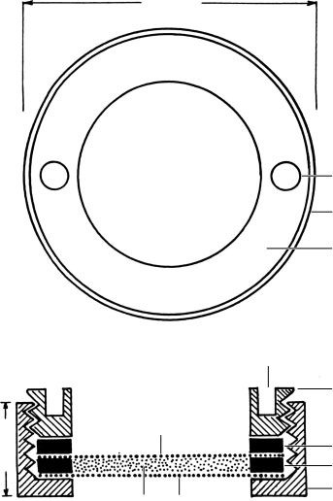
16
mm
5
5
1
2
3
4
6
7
6
mm
8
4
1
Fig. 7. Brass chamber for critical-point drying of protists (from Foissner, 1991). 1, threaded chamber lid; 2, washer 2; 3, washer 1; 4, threaded chamber jacket; 5, holes for forceps tips, used to screw lid into jacket; 6, top net; 7, sample; 8, bottom net.

Reagents
Parducz’ fixative (prepare immediately before use)
4 ml aqueous 2 % osmium tetroxide (OsO₄) 1 ml saturated, aqueous mercuric chloride (HgCl₂; for preparation see protargol protocol)
Deciliation of ciliates for scanning electron microscopy (SEM)
The methods available for deciliation of ciliates are either rather complex or very specific, that is, deciliate only certain species, usually Tetrahymena or Paramecium (Nelson, 1995, Thompson et al., 1974). In searching for an easier and better method, I obtained excellent results for rather many taxa with ordinary liquid soap. Experiments with 30 surfactants showed that many have deciliating properties, but excellent results were obtained only with liquid soap (Teepol, see below), Marlon AS3, and Nonidet P40. The method is quite simple and produces pictures of unseen clarity, although the adoral membranelles are rarely completely deciliated, showing that their cilia have different properties (Fig. 6).
Procedure
  - Use dense cultures or concentrate ciliates by mild centrifugation (~1500 r.p.m.).
  - Transfer ciliates with about 1 ml of medium into a watchglass and add 1 ml deciliation fluid. Mix by moving the watch-glass.
  - Control deciliation under the dissecting microscope. Assoon as most specimens have become motionless and sink to the bottom of the watch-glass, usually within 30–90 s, put the sample into 3–4 ml of Parducz’ fixative for about 30 min.
  - Proceed with step 2 of ‘Preparation for SEM’.
Remarks: To get sufficient material and some variation, two or three samples should be made with either the same or different surfactants and united to a composite sample. Excellent results are obtained with most Oligohymenophora (Fig. 6a, b, e–f) but Paramecium works only with Nonidet. Good results are obtained with some colpodids and prostomatids, while heterotrichs, hypotrichs and haptorids do not work, at least with the few species tested: Blepharisma, Condylostomides, Sterkiella, Kahliella, Epispathidium, and Dileptus. With some patience, it may be possible to find a surfactant or a compound surfactant which also deciliates these ciliates.
Reagents
    - Parducz’ fixative as described in ‘Preparation for
SEM’
    - Deciliation reagents. Dilute in 1 l tap water either0.5 ml Teepol, 0.005–0.05 ml Marlon AS3, or 0.25 ml Nonidet P40
Remarks: Teepol , the liquid soap, can be obtained in drugstores in Austria or from the distributer: Sara Lee HBC, Austria. Teepol consists of three surfactants: sodiumlaurylethersulfat (CAS-No.: 68891-38-3), alkylpolyglycolether (CAS-No.: 68131-39-5) and alkylbenzenesulfonic acid (CAS-No.: 85117-49-3). Experiments showed that the alkylbenzenesulfonic acid is the main deciliating agent. It is distributed under the commercial name MARLON AS3 by Sasol Germany. Nonidet P40 , which works as well as Teepol, is a compound surfactant composed of 15 homologues and distributed by AppliChem, Germany
Labelling and deposition of preparations
Labelling. Concise labelling of the slides is important. However, the most important information must be selected because of restricted space on the microscope slide. We label our slides usually as shown in Fig. 8. If necessary, additional information can be provided in the publication and/or on a stiff paper slide. Clean the slide carefully and then mark the specimens on the coverslip with a sharp pen using Indian ink. Avoid artificial ink because it usually bleaches within a few years.
Deposition. Corliss (1963) was among the first who emphasized the deposition of permanent preparations of new or reinvestigated ciliates in acknowledged repositories. His appeal was successful, i.e. most scientific journals now require the deposition of type slides (Lynn & Simpson, 2009), and the discussion of the scientific value of types has been rejuvenated (Aescht, 2008).
Basically, there are three kinds of types in ciliates (for details, see the International Code of Zoological Nomenclature, 1999). Briefly, the holotype is the one specimen or illustration designated by the author as the nomenclatural type (type specimen, name-bearing type). All specimens other than the holotype are paratypes, i.e. the holotype and the paratype(s) are from the same population and (type) locality. Vouchers, in contrast, are from other populations and localities. Typification guidelines and acknowledged repositories for preparations of unicellular organisms have been compiled by Aescht (2008).
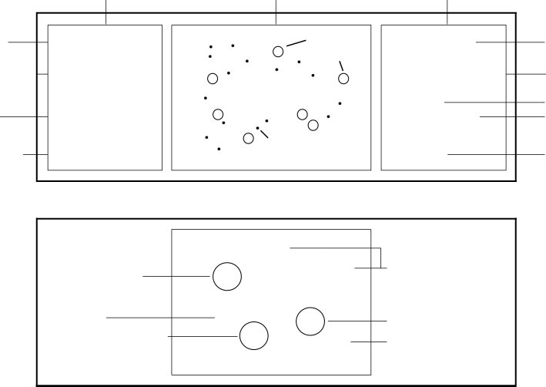
microscope (glass) slide
coverslip
marker
country
JAMAICA
Bromeliads from
Blue Mountains NP
Protargol
)
(
Foiss. meth.
2012/127
name of species
additional information
kind of material
name of preparator
habitat and
region
preparation
method
registraton numbe
r
in repository
rings
left label
Bromeliophrya
quadristicha
(
semipure culture
)
HOLOTYPE
specimens
further, unmarked
specimens
FOISSNER 2012
Bomeliophrya
quadristicha
HOLOTYPE
P
P
P
PD
H
MG
paratypes not drawn
in publication
holotype
morphogenesis not
drawn in publication
paratype
paratype drawn and
shown in publication
MGD
underlaid by a stiff paper slide explaining the ink rings
right label
morphogenesis
(
ontogenetic stage drawn
and shown in publication)
Fig. 8. Labelling of permanent preparations.

Any kind of type should be deposited in an appropriate slide box and in an acknowledged repository, usually a museum of natural history. Avoid deposition in the laboratory because your follower may be ignorant of the importance of types and thus may dispose of the slides.

ACKNOWLEDGEMENTS
Thanks to Professor Micah Dunthorn for inviting this review. For technical assistance, I am grateful to Mag. B. Komm, R. Scho¨rghofer and A. Zankl. Financial support was provided by the Austrian Science Fund (P20360–B17 and P22846–B17).

REFERENCES
Adam, H. & Czihak, G. (1964). Arbeitsmethoden der makroskopischen und mikroskopischen Anatomie. Ein Laboratoriumshandbuch fu¨r Biologen, Mediziner und technische Hilfskra¨fte. Stuttgart: G. Fischer.
Aescht, E. (2008). Annotated catalogue of ‘‘type material’’ - of ciliates (Ciliophora) and some further protists at the Upper Austrian Museum in Linz, including a guideline for ‘‘typification’’ of species. Denisia 23, 125–234.
Aufderheide, K. J. (1982). An improvement in the protargol technique of Ng and Nelsen. Trans Am Microsc Soc 101, 100–104.
Augustin, H., Foissner, W. & Adam, H. (1984). An improved pyridinated silver carbonate method which needs few specimens and yields permanent slides of impregnated ciliates (Protozoa, Ciliophora). Mikroskopie 41, 134–137.
Chatton, E. (1940). Sur une me´thode rapide d’impregnation a l’argent re´duit par 1’hydroquinone. C R Se´anc Soc Biol 134, 229–232 (in French).
Chatton, E. & Lwoff, A. (1930). Impre´gnation, par diffusion argentique, de l’infraciliature des cilie´s marins et d’eau douce, apre`s fixation cytologique et sans dessiccation C R Se´anc Soc de Biol 104, 834–836 (in French).
Chatton, E. & Lwoff, A. (1936). Techniques pour 1’e´tude des protozoaires, spe´cialement de leurs structures superficielles (cine´tome et argyrome). Bull Soc Fr Microsc 5, 25–39 (in French).
Corliss, J. O. (1953). Silver impregnation of ciliated protozoa by the Chatton-Lwoff technic. Stain Technol 28, 97–100.
Corliss, J. O. (1963). Establishment of an international type-slide collection for the ciliate protozoa. J Protozool 10, 247–249.
Corliss, J. O. (1979). The Ciliated Protozoa. Characterization, Classification and Guide to the Literature, 2nd edn. Oxford, Frankfurt: Pergamon Press.
Dieckmann, J. (1995). An improved protargol impregnation for ciliates yielding reproducible results. Eur J Protistol 31, 372–382.
Dragesco, J. (1962). L’orientation actuelle de la syste´matique des cilie´s et la technique d’impre´gnation au prote´inate d’argent. Bull Microsc Appl 11, 49–58 (in French).
Dragesco, J. & Dragesco-Kerne´is, A. (1986). Cilie´s libres de l’Afrique intertropicale. Introduction a` la Connaissance et a` l’E´tude des Cilie´s (Collection Faune Tropicale no. 26). Paris: ORSTOM (in French).
Ferna´ndez-Galiano, D. (1976). Silver impregnation of ciliated protozoa: procedure yielding good results with the pyridinated silver carbonate method. Trans Am Microsc Soc 95, 557–560.
Foissner, W. (1976). Erfahrungen mit einer trockenen Silberimpra¨gnationsmethode zur Darstellung argyrophiler Strukturen bei Protisten. Verh Zool Bot Ges Wien 115, 68–79 (in German).
Foissner, W. (1977). Electronmicroscopical studies on the argyrophilic structures of Colpidium campylum (Ciliata, Tetrahymenidae). Acta Biol Acad Sci Hung 28, 59–72.
Foissner, W. (1979). Methylgru¨n-Pyronin: Seine Eignung zur supravitalen Ubersichtsfa¨rbung von Protozoen, besonders ihrer Protrichocysten. Mikroskopie 35, 108–115 (in German).
Foissner, W. (1981). Das Silberliniensystem der Ciliaten: Tatsachen, Hypothesen, Probleme. Mikroskopie 38, 16–26 (in German).
Foissner, W. (1991). Basic light and scanning electron microscopic methods for taxonomic studies of ciliated protozoa. Eur J Protistol 27, 313–330.
Foissner, W. (2005). Two new ‘‘flagship’’ ciliates (Protozoa, Ciliophora) from Venezuela: Sleighophrys pustulata and Luporinophrys micelae. Eur J Protistol 41, 99–117.
Foissner, W. (2013). Description of Glaucomides bromelicola n. gen., n. sp. (Ciliophora, Tetrahymenida), a macrostome forming inhabitant of bromeliads (Bromeliaceae), including redescriptions of Glaucoma scintillans and G. reniformis. J Eukaryot Microbiol 60, 137–157.
Foissner, W. & Al-Rasheid, K. (2006). A unified organization of the stichotrichine oral apparatus, including a description of the buccal seal (Ciliophora: Spirotrichea). Acta Protozool 45, 1–16.
Foissner, W. & Foissner, I. (1988). The Fine Structure of Fuscheria terricola Berger et al., 1983 and a proposed new classification of the subclass Haptoria Corliss, 1974 (Ciliophora, Litostomatea). Arch Protistenk 135, 213–235.
Foissner, W., Wolf, K. W., Yashchenko, V. & Stoeck, T. (2011). Description of Leptopharynx bromelicola n. sp. and characterization of the genus Leptopharynx Mermod, 1914 (Protista, Ciliophora). J Eukaryot Microbiol 58, 134–151.
Frankel, J. & Heckmann, K. (1968). A simplified Chatton-Lwoff silver impregnation procedure for use in experimental studies with ciliates. Trans Am Microsc Soc 87, 317–321.
Gelei, J. v. (1934). Eine mikrotechnische Studie u¨ber die Fa¨rbung der subpellicula¨ren Elemente der Ciliaten. Z Wiss Mikrosk 51, 103–178 (in German).
Gelei, J. v. (1935). Eine neue Aba¨nderung der Klein’schen trockenen Silbermethode und das Silberliniensystem von Glaucoma scintillans. Arch Protistenk 84, 446–455 (in German).
Gelei, G. v. (1939). Neue Silbermethoden im Dienste der Protistenforschung (Komplexsilberverbindungen). Z Wiss Mikrosk Leipzig 56, 148–180 (in German).
Hiller, S. A. (1991). Bursellopsis spaniopogon n. spec. (Ciliophora: Prostomatida): I. Infraciliature and ultrastructure of the somatic and oral cortex. Eur J Protistol 27, 1–16.
Hiller, S. A. & Bardele, C. F. (1988). Prorodon aklitolophon n. spec. and the ‘‘dorsal brush’’ as a character to identify certain subgroups in the genus Prorodon. Arch Protistenk 136, 213–236.
Horva´th, J. v. (1938). Eine neue Silbermethode fu¨r die Darstellung der erregungsleitenden Elemente der Ciliaten. Z Wiss Mikrosk 55, 113–122 (in German).
International Commission on Zoological Nomenclature (1999). International Code of Zoological Nomenclature, 4th edn. London, UK: International Trust for Zoological Nomenclature.
Kirby, H. (1945). The structure of the common intestinal trichomonad of man. J Parasitol 31, 163–174.
Kirby, H. (1950). Materials and Methods in the Study of Protozoa. Univ Calif Press, Berkely.
Klein, B. M. (1926). U¨ ber eine neue Eigentu¨mlichkeit der Pellicula von Chilodon uncinatus Ehrbg. Zool Anz 67, 1–2 (in German).
Klein, B. M. (1943). Das Silberlinien- oder neuroformative System der Ciliaten. Ann Nat -Hist Mus Wien 53, 156–336 (in German).
Klein, B. M. (1958). The ‘‘dry’’ silver method and its proper use. J Protozool 5, 99–103.
Larsen, H. F. (1975). Fa¨rbung von Protozoen mit Azur A. Mikrokosmos, issue 9, 264–265 (in German).
Lee, J. J., Small, E. B., Lynn, D. H. & Bovee, E. C. (1985). Some techniques for collecting, cultivating and observing protozoa. In An Illustrated Guide to the Protozoa, pp. 1–7. Edited by J. J. Lee, S. H. Hunter & E. C. Bovee. Lawrence, KS: Allen Press.
Lynn, D. H. & Simpson, A. G. B. (2009). From the editors: describing new taxa of unicellular protists. J Eukaryot Microbiol 56, 403– 405.
Lynn, D. H., Suriano, D. M. & Beverley-Burton, M. (1981). ChattonLwoff silver impregnation: an improved technique for the study of oncomiracidia (Platyhelminthes: Monogenea) chaetotaxy. Syst Parasitol 3, 21–23.
Ma, H., Choi, J. K. & Song, W. (2003). An improved silver carbonate impregnation for marine ciliated protozoa. Acta Protozool 42, 161– 164.
McCoy, J. W. (1974). New features of the tetrahymenid cortex revealed by protargol staining. Acta Protozool 13, 155–160.
Montagnes, D. J. S. & Lynn, D. H. (1987). A quantitative protargol stain (QPS) for ciliates: method description and test of its quantitative nature. Mar Microb Food Webs 2, 83–93.
Moskowitz, N. (1950). The use of protein silver for staining protozoa. Stain Technol 25, 17–20.
Nelson, D. L. (1995). Preparation of cilia and subciliary fractions from Paramecium. Methods Cell Biol 47, 17–24.
Ng, S. F. & Nelsen, E. M. (1977). The protargol staining technique: an improved version for Tetrahymena pyriformis. Trans Am Microsc Soc 96, 369–376.
Pan, X., Bourland, W. A. & Song, W. (2013). Protargol synthesis: an inhouse protocol. J Eukaryot Microbiol 60, 609–614.
Peck, R. K. (1974). Morphology and morphogenesis of Pseudomicrothorax, Glaucoma and Dexiotricha, with emphasis on the types of stomatogenesis in holotrichous ciliates. Protistologica (Paris) 10, 333– 369.
Roberts, D. McL. & Causton, H. (1988). Silver nitrate impregnation of ciliated protozoa. Arch Protistenk 135, 299–318.
Romeis, B. (1968). Mikroskopische Technik. Mu¨nchen, Wien: R. Oldenbourg Verlag.
Ruzicka, F. K. (1966). Eine neue Methode zur Darstellung des Silberliniensystems bei Wimpertieren. Mikrokosmos, issue 6, 180–183 (in German).
Skibbe, O. (1994). An improved quantitative protargol stain for ciliates and other planktonic protists. Arch Hydrobiol 130, 339– 347.
Tellez, C., Small, E. B., Corliss, J. O. & Maugel, T. K. (1982). The ultrastructure of specimens of Paramecium multimicronucleatum impregnated with silver by the Ferna´ndez-Galiano method. J Protozool 29, 627–634.
Thompson, G. A., Jr, Baugh, L. C. & Walker, L. F. (1974). Nonlethal deciliation of Tetrahymena by a local anesthetic and its utility as a tool for studying cilia regeneration. J Cell Biol 61, 253–257.
Tuffrau, M. (1964). Quelques variantes techniques de l’impre´gnation des cilie´s par le prote´inate d’argent. Archs Zool exp ge´n 104, 186–190 (in French).
Tuffrau, M. (1967). Perfectionnements et pratique de la technique d’impre´gnation au protargol des infusoires cilie´s. Protistologica (Paris) 3, 91–98 (in French).
Wilbert, N. (1975). Eine verbesserte Technik der Protargolimpra¨gnation fu¨r Ciliaten. Mikrokosmos, issue 6, 171–179 (in German).
Wilbert, N. (1976). A standardized method for identifying and counting the vagile and sessile periphyton. Oecologia 24, 343–347.
Wilbert, N. (1983). Eine neue Impra¨gnation der Basalko¨rper bei Wimpertieren: Silberimpra¨gnation mit Pyridin-Silberkarbonat nach Fernandez-Galiano. Mikrokosmos, issue 7, 193–197 (in German).
Wolska, M. (1966). Application of the ammonium-silver impregnation method to the investigation of ciliates from the rumen of herbivorous mammals. Acta Protozool 4, 105–108.
Zagon, I. S. (1970). Carchesium polypinum: cytostructure after protargol silver deposition. Trans Am Microsc Soc 89, 450–468.

